

Version 0.4

**Solution Design Document**

**Optimus Disputes (3577)**

Trading Style

numero is a trading name of Smart Analytics Limited, whose registered address is One Park Lane, Leeds, LS3 1EP. Company No. 4127933.

Copyright

The information contained within this document is the property of numero. This information is issued in confidence to the intended recipients only and must not be reproduced, used or disclosed in whole or in part or given or otherwise communicated to any third party without the prior written permission of numero.

Disclaimer

Any advice given or statements or recommendations made shall not in any circumstances constitute or be deemed to constitute a warranty by numero as to the accuracy of such advice, statements or recommendations. numero shall not be liable for any loss, expense, damage or claim arising out of the advice given or not given or statements made or omitted in connection with this document.

Document Control

Amendment History

|  |  |  |  |
| --- | --- | --- | --- |
| Revision | Date Issued | Author | Reason for Change / Description |
| V0.1 |  | Andrew Simmers / Kevin Wing | Initial Draft |
| V0.2 |  | Andrew Simmers / Kevin Wing / David Bishop | Addition of Technical Architecture and Interfaces |
| V0.3 |  | Susan Lumley-Smith | Document Acceptance |
| V0.4 |  | Kevin Wing | Minor Amendments to Screen Design Components and Terminology |

Related Documents

|  |  |  |
| --- | --- | --- |
| Ref No. | Author | Title |
| 1 | David Bishop | Technical Design Document |
| 2 | Susan Lumley Smith | Project Initiation Document |
| 3 | John Webb | Optimus Supplier Portal Solution Design Document |
| 4 |  | PCI Compliance Report |
| 5 |  | GDPR Compliance Report |
| 6 | Nick Graham | Project Optimus - Consumer Notifications 20160211 |

Document Acceptance

|  |  |  |  |
| --- | --- | --- | --- |
| On behalf of | Name | Title | Acceptance Date |
| Callcredit | Chris Rodgers | Project Manager |  |
| Callcredit | Nicholas Graham | Business Analyst |  |
| Callcredit | Lambros Lambrou | Lead Solution Architect |  |
| Callcredit | Lee Scott | Head of Contact Centre |  |
| Callcredit | Chris Harris | Dispute Manager |  |
| numero | Mike Walker | Head of Delivery |  |
| numero | Susan Lumley Smith | Project Manager | 31/10/2017 |

Contact Details

Please address any queries regarding this document to:

Andrew Simmers / Kevin Wing / David Bishop

numero

Kingfisher Court

Yew Street

Stockport

Cheshire

SK4 2HG

Email: [andrew.simmers@callcreditgroup.com](mailto:andrew.simmers@callcreditgroup.com) / [kevin.wing@callcreditgroup.com](mailto:kevin.wing@callcreditgroup.com) / [david.bishop@callcreditgroup.com](mailto:david.bishop@callcreditgroup.com)

**CONTENTS**

1 Introduction 10

1.1 Background 10

1.2 Purpose of this Document 11

1.3 Structure of this Document 11

1.4 Scope 11

1.4.1 Scope Definitions 11

1.4.2 In Scope 11

1.4.3 Out of Scope 13

2 Operational Architecture 14

2.1 Consumers 14

2.2 Consumer Services Team Agent (Leeds) 14

2.3 Consumer Data Processing Agent 14

2.4 Consumer Data Processing Senior Agent 15

2.5 Consumer Data Processing Team Leader 15

2.6 Suppliers 15

2.7 Data Services Data Amendment Analyst 15

2.8 Data Services Manager 15

2.9 Head of Consumer Data Processing and Data Services 15

2.10 Administrator 16

3 Technical Architecture 17

3.1 Components 17

3.1.1 numero interactive 17

3.1.2 numero interactive Client 17

3.1.3 Noddle / Reseller Websites 17

3.1.4 Supplier Portal 18

3.1.5 Share Amend 18

3.1.6 Call Report 18

3.1.7 Bureau 18

3.1.8 CIG Databases 18

3.1.9 Mail Server 18

3.1.10 File Share 18

3.1.11 Printer 18

4 Interfaces 19

4.1 IF101 – Inbound Emails 19

4.2 IF102 – Receive Dispute API 19

4.3 IF103 – Inbound Whitemail Gateway 19

4.4 IF104 – Log Exceptions 20

4.5 IF105 – Outbound Emails 20

4.6 IF106 – Outbound Whitemail 21

4.7 IF107 – Submit Disputes Case 21

4.8 IF201 – Alert Schedule 21

4.9 IF202 – Data Fix Rules 22

4.10 IF203 – Exception Rules 22

4.11 IF204 – Get Auto Processing Rules 23

4.12 IF205 – Get Dispute Data 23

4.13 IF206 – Get Previous Cases 23

4.14 IF207 – Get Validation Rules 24

4.15 IF210 – Update Disputes 24

4.16 IF301 – Get Consumer 25

4.17 IF302 – Get Credit Report 25

4.18 IF303 – Get Sub Report 25

4.19 IF304 – Suppress Credit Report Line Item 26

4.20 IF305 – Un-Suppress Credit Report Line Item 26

4.21 IF306 – Remove Search 26

4.22 IF401 – Add NOD 27

4.23 IF402 – Data Fix Interfaces 27

4.24 IF403 – Remove NOD 28

4.25 IF601 – Send Notification 28

5 Data Architecture 29

5.1 Customer, Case and Workitem Relationships 29

5.1.1 Internal numero interactive data relationships 29

5.2 Dispute Case Data 29

5.2.1 Consumer Data 29

5.2.2 Dispute Data 30

5.2.3 Dispute Case Data 31

5.3 Reference Data 32

5.3.1 Supplier Data 32

5.3.2 Case States 32

5.3.3 Noddle/Reseller Notifications 32

5.3.4 Rejection Reasons 32

5.3.5 Sources 33

5.3.6 Dispute Types 33

5.3.7 Alert Schedule 33

5.3.8 Data Update Rules 33

5.3.9 Exception Rules 33

5.3.10 Auto Processing Rules 33

5.3.11 Validation Rules 34

5.3.12 SLA Schedule 34

6 Dispute Processes 35

6.1 Overview 35

6.2 State Model 36

6.3 Receive Dispute 37

6.3.1 Receive Dispute 38

6.3.2 Submit Dispute to numero 38

6.3.3 Company / Category Allocation 38

6.3.4 Case and Customer Allocation 39

6.3.5 Check originating source 40

6.3.6 Work Allocation 40

6.3.7 Process Dispute Request 40

6.3.8 Submit Dispute 40

6.3.9 Request Further Information 41

6.4 Dispute Triage 42

6.4.1 Dispute Validation 43

6.4.2 Dispute Auto Processing 43

6.5 Consumer Data Processing From Triage 45

6.5.1 Work Allocation 46

6.5.2 Investigate Dispute 46

6.5.3 Request Further Information 47

6.6 Consumer Data Processing From Supplier 48

6.6.1 Monitor Supplier Responses 49

6.6.2 Spawn Response Workitem 49

6.6.3 Auto process response? 49

6.6.4 Work Allocation 49

6.6.5 Review Supplier Responses 49

6.7 Consumer Data Processing From Data Services 51

6.7.1 Work Allocation 52

6.7.2 Check Data Fix 52

6.8 Data Services Processing 53

6.8.1 Work Allocation 54

6.8.2 Review and Action Data Fix 54

6.8.3 Check Data Fix 54

6.9 Supplier Dispute Processing 55

6.9.1 Setup Supplier Alert Schedule 56

6.9.2 Send Supplier Notification 56

6.9.3 Supplier Portal Dispute Management 56

6.10 Data Updates 57

6.10.1 Asses Data Fix 58

6.10.2 Fix Type? 58

6.10.3 Data Fix / Suppression Successful? 58

6.11 Exception Handling 59

6.11.1 Assess Exception 60

6.11.2 Work Allocation 60

6.11.3 Process Exception 60

6.12 Dispute SLA Monitor 61

6.12.1 SLA Monitor 62

6.12.2 Spawn Work Item Notification 62

6.12.3 Work Allocation 62

6.12.4 Consumer Data Processing (From Supplier) 62

6.13 Receive Correspondence 63

6.13.1 Numero Gateway 64

6.13.2 Company / Category Allocation 64

6.13.3 Case /Customer Allocation 64

6.13.4 Work Allocation 64

6.13.5 Investigate Dispute 64

6.13.6 Request Further Information 65

6.14 Dispute Notifications & Correspondence 66

6.14.1 Generate Noddle Notification 67

6.14.2 Send Auto Correspondence? 67

6.14.3 Check correspondence preference 67

6.14.4 Generate Automatic Correspondence 67

6.14.5 QA Process 68

7 Dispute Forms 69

7.1 Screen Flow 69

7.2 Log Dispute 70

7.2.1 Identify Consumer 70

7.3 Case Linking 71

7.3.1 Log Dispute 71

7.3.2 Case Actioning 72

7.3.3 Form Usage 72

7.4 Dispute Case Home 73

7.4.1 Case Header 74

7.4.2 Alerts 74

7.4.3 Consumer Details 74

7.4.4 Dispute Details 75

7.4.5 Case Actioning 78

7.4.6 Case Stats 78

7.4.7 Case History 78

7.4.8 Form Usage 79

7.5 Dispute Case Home Supplier Response 80

7.5.1 Supplier Responses 80

7.5.2 Case Actioning 80

7.5.3 Form Usage 80

7.6 Data Update Request 81

7.6.1 Data Fix Description 81

7.6.2 Confirmation 81

7.6.3 Form Usage 81

7.7 Send to Suppliers 82

7.7.1 Supplier Details 82

7.7.2 Comments 82

7.7.3 Confirmation 82

7.7.4 Form Usage 82

7.8 Data Services Case Home 83

7.8.1 Data Fix Details 83

7.8.2 Case Actioning 83

7.8.3 Confirmation 84

7.8.4 Form Usage 84

7.9 File Merge Request 85

7.9.1 File Merge Details 86

7.9.2 Confirmation 86

7.9.3 Form Usage 86

7.10 Dispute Case Home Exception Handling 87

7.10.1 Exception Details 87

7.10.2 Case Actioning 87

7.10.3 Form Usage 87

7.11 Complete 88

7.11.1 Status 88

7.11.2 Reason 88

7.11.3 Comments 88

7.11.4 Confirmation 89

7.11.5 Form Usage 89

8 Case Actioning 90

8.1 All Dispute Types 90

8.1.1 Is the dispute valid? 90

8.1.2 Data belongs to consumer? 91

8.1.3 Has the data already been corrected? 91

8.1.4 Proceed with case? 91

8.2 Address Link 92

8.2.1 Share or public data under link? 92

8.2.2 Is source Callcredit or Eurodirect? 92

8.2.3 Only 1 address link? 92

8.2.4 Data belongs to different address? 92

8.3 Alias Link 93

8.3.1 Is the source Callcredit or Eurodirect? 93

8.4 Associate Link 94

8.4.1 Active joint accounts found? 94

8.4.2 Associate Deceased 94

8.5 Public 95

8.5.1 Evidence received? 95

8.5.2 Evidence acceptable? 95

8.5.3 Data requires amendment? 95

8.6 Search 96

8.6.1 Callcredit search 96

8.6.2 Can Callcredit search be removed? 96

8.7 Share/MODA 97

8.8 Exceptions 98

8.8.1 Resubmit the data fix request? 98

8.8.2 Edit data fix request and resubmit? 98

8.8.3 Send the fix to Data Services? 98

8.9 Check Data Services Fix 99

8.9.1 Data Fix Successful? 99

8.10 Check Supplier Responses 100

8.10.1 Search Dispute 100

8.10.2 Share/MODA Dispute 100

8.10.3 Address/Alias Link Dispute 100

9 Work Distribution 101

10 Management Information 102

10.1 Standard Reports 102

10.2 Bespoke Reports 102

10.3 BI Extracts 103

# Introduction

## Background

The aim of the project is to design, build and deploy a numero interactive and Supplier Portal solution to manage credit report disputes raised by consumers to Callcredit.

The diagram below provides an overview of the proposed To Be Disputes processing solution.

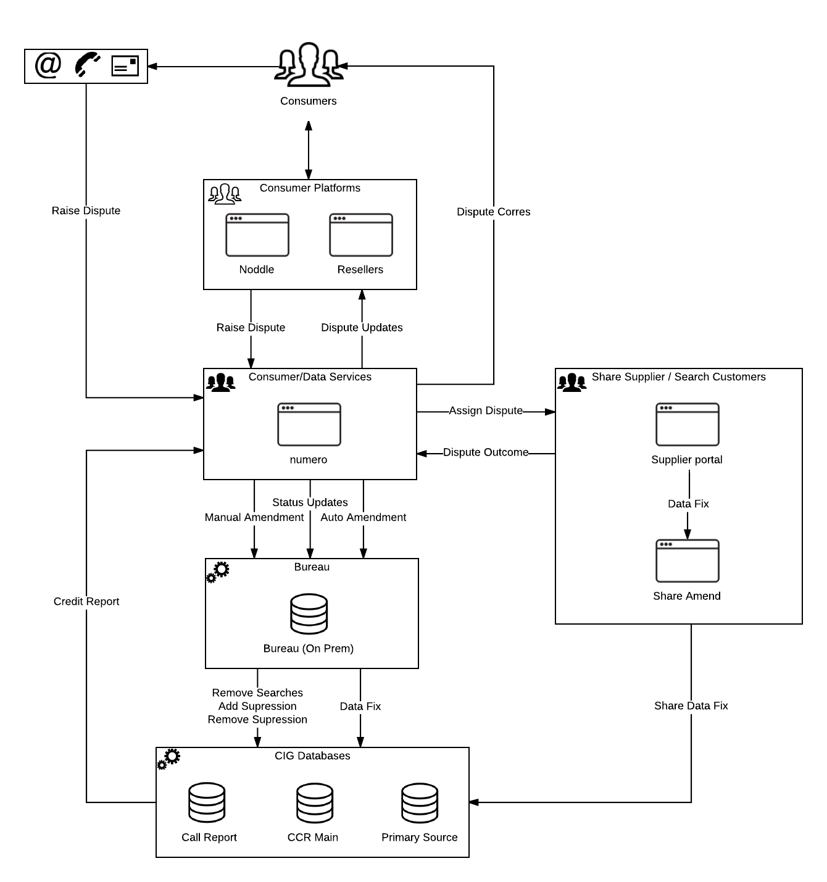

## Purpose of this Document

The purpose of the Solution Design Document (SDD) is to communicate the high level design of the numero interactive solution, for agreement between all interested parties. This provides a project baseline from which change control is possible. The solution design is defined within the SDD to a sufficient level of detail to enable the Build phase to be planned and commenced; further detailed design activity will occur during the Build phase as required, within the context of the SDD.

## Structure of this Document

The SDD describes the high level design of the numero interactive solution as follows:

* The *operational architecture*, defined as the user roles and their key interactions with the numero interactive solution.
* The *solution architecture*, defining the system interactions between the numero interactive solution and other Callcredit systems.
* The *system interfaces* required between numero interactive and other Callcredit systems.
* The *data architecture*, defining the key system concepts of case and customer.
* The *business processes* embodied within the solution, defined in terms of Process and User Interface diagrams.
* *Management Information* to support the business processes.

The document reflects the current understanding of both the requirements, and the proposed solution and forms part of the basis upon which numero will commence the Build phase.

Any changes to the scope of this document beyond the SDD sign-off date will be managed under project change control.

Note:

The Supplier Portal design is described in the Optimus Supplier Portal Solution Design Document (Ref 3).

## Scope

### Scope Definitions

The definitions of scope below make reference to numero’s delivery approach and project phases. These are defined in more detail in the Project Initiation Document (PDD, Ref 2).

#### Requirements Coverage

The scope of the proposed solution is defined within this SDD at a high level; this document does not capture detailed design. Numero consultants will continue to work collaboratively throughout the project’s Build phase to define and implement the solution within the context of the SDD.

#### Infrastructure Definition

While this document defines the high level solution architecture within which the numero interactive solution will reside, no definition of the physical hardware or server topology is provided. This is to be established through technical discussions with the relevant project team members and the production / sign off of the Technical Design Document (TDD, Ref 1).

#### Interface Definition

This document outlines each interface required between numero interactive and other Callcredit systems within the proposed solution architecture.

The minimum logical interfaces required to support the proposed solution are specified in this SDD, but are not however intended to constrain the final solution or act as a physical design. The project team will work collaboratively throughout the project’s Build phase in order to establish physical implementations of these interfaces, to identify any further beneficial inputs / outputs for the described interfaces and where feasible implement these in the solution.

### In Scope

|  |  |
| --- | --- |
| Feature | Comments |
| Automatic Dispute case logging | Dispute cases are automatically raised from:   * Noddle * Resellers |
| Manual Dispute case logging | Dispute cases are raised manually for the following channels:   * Email * Letter * Telephone |
| Dispute Types | Each Dispute Type detailed below map to a single numero category:   * Address Links * Alias Links * Associate Links * Public * Share/MODA * Search |
| Outbound correspondence | The system is configured to send outbound correspondence on the following channels:   * Email * Letter |
| Noddle/Reseller notifications | The system is configured to send Noddle / Reseller notifications at appropriate stages in the case handling processes. |
| Dispute grouping | The system is configured to group Disputes received from a consumer within a specified time period. |
| Dispute auto-processing | Where possible the system is configured, using pre-defined rules, to auto process Dispute cases:   * Dispute validation * Automatic routing * Automatic resolution   Auto processing rules can be switched off and on real-time. |
| Manual Dispute Processes | Where automatic processing is not possible numero provides the manual handling workflow processes to route the Dispute case to the appropriate team(s) for resolution.   * Consumer Data Processing * Data Services * Suppliers |
| Exception Handling | Management of exceptions received from the bureau update processes. |
| Dispute SLA Monitoring | Automatic management of the ’28 SLA processes’ for Dispute cases that have been sent to a supplier. |
| Supplier Alerts | Configurable alert schedules for automatic supplier chasers. |
| Numero Flows application | All agent interactions with the Dispute case are managed in a numero flows application embedded within the numero workitem, case and/or customer. |
| Integration | Integration to Call Report and Bureau Stored Procedures. |
| Management Information | Provision of the standard numero reporting pack and 3 bespoke operational case reports. |
| BI Extract | Provision of data extracts for BI. |

### Out of Scope

This section is not intended to be an exhaustive list of out-of-scope items; instead, those items considered to be significant to the Solution Design are explicitly identified below.

|  |  |
| --- | --- |
| Feature | Comments |
| Manual logging of Supplier responses | It is assumed that all suppliers are integrated using the Supplier Portal. |
| Azure APIs | All integration for Data Updates and applying NoDs/Sups is managed through the existing stored procedures (or new stored procedures built in existing infrastructure). |
| Credit Report Screen Scraper | All views of the credit report are displayed using numero Flows forms. |
| Outbound Letters ? |  |
| NOC ? |  |

# Operational Architecture

The sections below identify the key user roles of the numero interactive solution, broadly describing each of their required uses.

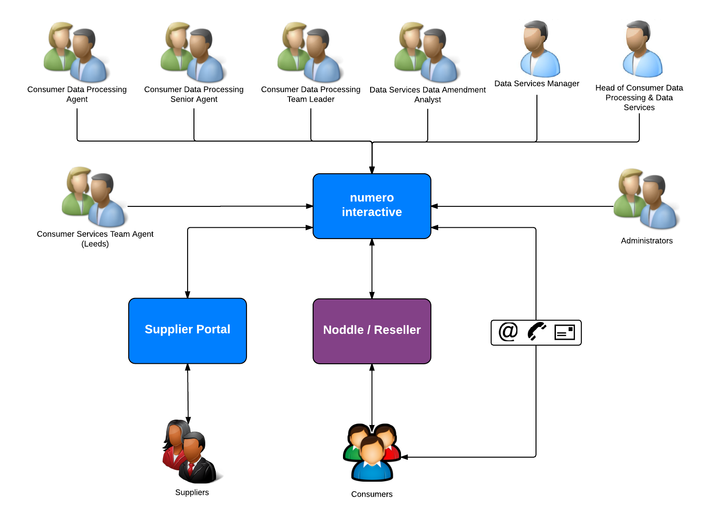

## Consumers

* Raise Dispute via Noddle/Reseller/Email/Phone/Letter
* Receive Dispute outcome via Email/Letter
* Receive Dispute notifications via Noddle/Reseller
* Respond to requests for further information and evidence

## Consumer Services Team Agent (Leeds)

* Raise Dispute Cases on behalf of a consumer from Phone/Email/Letter

## Consumer Data Processing Agent

* Receive Disputes direct from Noddle/Reseller
* Raise Dispute cases received from non-integrated reseller emails
* Receive Disputes logged by Consumer Services Team (Leeds)
* Investigate and resolve Dispute cases
* Send Dispute outcome email/letter to Consumer
* Submit Data Update Request
* Pass Dispute to Data Services
* Pass Dispute to Suppliers
* Receive Dispute outcome from Suppliers
* Receive cases from Data Services
* Receive requests for further information from Suppliers
* Send requests for further information and evidence to Consumers
* Receive responses to requests for information and evidence from Consumers
* Manage data fix exceptions

## Consumer Data Processing Senior Agent

As above +

* View operational MI
* QA Disputes set as Rejected
* QA Disputes set as Cancelled
* QA Dispute cases
* Manage content

## Consumer Data Processing Team Leader

* View operational MI
* Authorise users and set work management (e.g. group access)
* Manage content

## Suppliers

* Receive Dispute cases
* Resolve Dispute cases
* Fix data in Share Amend
* Notify Consumer Data Processing of Dispute outcome
* Request further information from Consumer Data Processing

## Data Services Data Amendment Analyst

* Receive Disputes cases from Consumer Data Processing
* Submit data fixes for Dispute cases
* Send Dispute cases to Consumer Data Processing
* Manage data fix exceptions

## Data Services Manager

* View operational MI
* Authorise users and set work management (e.g. group access)
* Manage content

## Head of Consumer Data Processing and Data Services

* View Operational MI

## Administrator

* Maintain supplier contact details.
* Maintain user and group membership.
* Maintain content used in outbound correspondence (templates and paragraphs).
* Access to relevant management information and queries to monitor the performance of their team.
* Manage permitted configuration parameters.

# Technical Architecture

The diagram below illustrates the high level architecture of the numero interactive solution, including the key interactions between each component in the architecture.

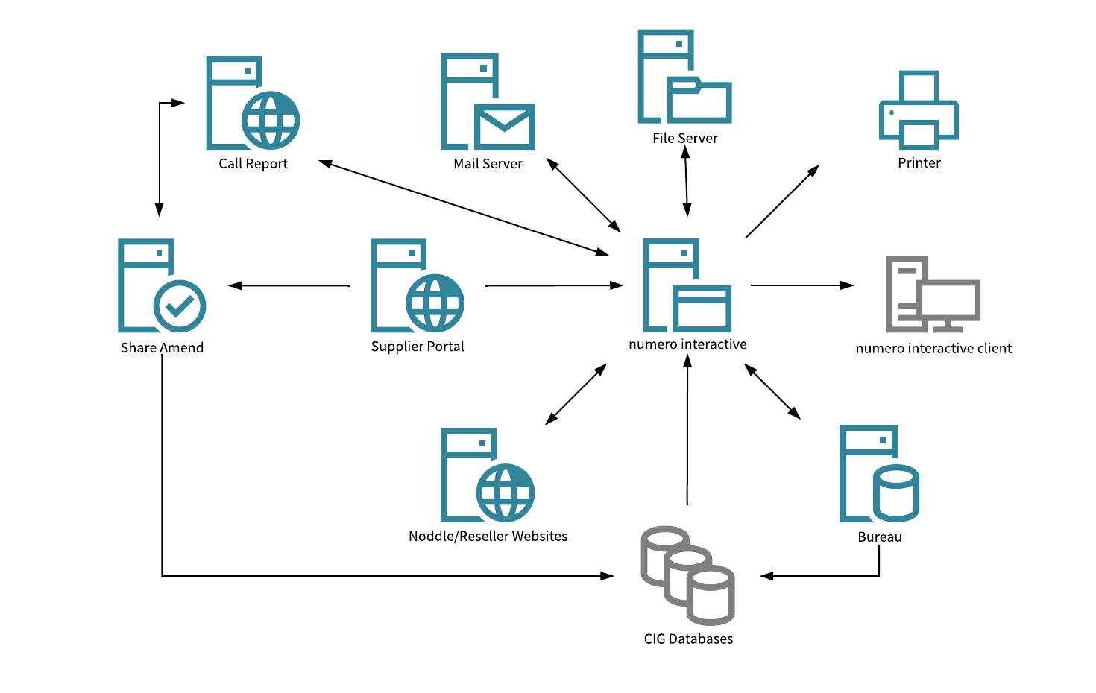

## Components

### numero interactive

* Generates workitems from disputes received via Noddle and Reseller websites.
* Generates workitems from disputes received via email, letter and manually logged telephone calls.
* Gets inbound letters and associated metadata from the file share.
* Gets consumer and credit report data from CIG Databases, and the Call Report website.
* Sends data update requests to the bureau for processing.
* Generates dispute case notifications to the Noddle and Reseller websites.
* Sends manual and automated outbound emails to the mail server.
* Creates manual and automated outbound letters for printing.
* Generate operational management Information including reports and queries.

### numero interactive Client

* Provides the User Interface for processing dispute cases, running and viewing MI and managing configuration.

### Noddle / Reseller Websites

* Send dispute cases into numero interactive.
* Receive dispute case notifications from numero interactive.

### Supplier Portal

Covered in detail in the Optimus Supplier Portal Solution Design Document (Ref 3).

### Share Amend

* Provides the User Interface for submitting data updates to the CIG Databases.

### Call Report

* Provides up to date consumer and credit data to numero interactive.
* Suppress / Un-suppress credit report line items.
* Provides stored procedures to remove searches.

### Bureau

* Message bus receiving automated and manual data update requests from numero interactive.
* Provides status updates on data updates to numero interactive.
* Provides source data for address and alias link disputes.

### CIG Databases

* Receives and processes data updates from the Bureau and Share Amend.

### Mail Server

* Receives inbound email messages from the consumer.
* Receives outbound email messages from numero interactive.

### File Share

* Receives inbound letters from the Callcredit scanning solution
* Receives outbound letters generated by numero interactive.

### Printer

* Prints outbound letters.

# Interfaces

Each of the interfaces required by numero interactive is listed below, including the key inputs and outputs required to support the business processes.

## IF101 – Inbound Emails

|  |  |  |  |  |
| --- | --- | --- | --- | --- |
| Ref. | Name | | Type | |
| IF101 | Inbound Emails | | Email Gateway | |
| Usage | | | | |
| Receives emails | | | |  |
| Calling Component | | Called Component | | |
| numero interactive | | Mail Server | | |
| Minimum Inputs | | Minimum Outputs | | |
| Email | | numero interactive inbound work item | | |

## IF102 – Receive Dispute API

|  |  |  |  |  |
| --- | --- | --- | --- | --- |
| Ref. | Name | | Type | |
| IF102 | Receive Dispute API | | Connect API Gateway (inbound) | |
| Usage | | | | |
| Receives dispute data from Noddle or Re-seller or manually submitted disputes. Creates a record in stash and runs the grouping rules. | | | |  |
| Calling Component | | Called Component | | |
| Noddle / Reseller / numero | | Connect API (Inbound) | | |
| Minimum Inputs | | Minimum Outputs | | |
| Dispute Data | | Stash object | | |

## IF103 – Inbound Whitemail Gateway

|  |  |  |  |  |
| --- | --- | --- | --- | --- |
| Ref. | Name | | Type | |
| IF103 | Inbound Whitemail Gateway | | XSL Polling Source | |
| Usage | | | | |
| Generates inbound workitems from a pdf and xml pair stored on a file share. | | | |  |
| Calling Component | | Called Component | | |
| Numero interactive | | File share | | |
| Minimum Inputs | | Minimum Outputs | | |
| Source ID | | numero interactive work item | | |
| Meta Data | |  | | |
| Document | |  | | |

## IF104 – Log Exceptions

|  |  |  |  |  |
| --- | --- | --- | --- | --- |
| Ref. | Name | | Type | |
| IF104 | Log Exceptions | | Connect – CreateNewWorkItem | |
| Usage | | | | |
| Creates an exception if the data fix does not work. | | | |  |
| Calling Component | | Called Component | | |
| Connect API | | Numero interactive | | |
| Minimum Inputs | | Minimum Outputs | | |
| Stash Row ID | | numero interactive work item | | |
| Exception data | |  | | |

## IF105 – Outbound Emails

|  |  |  |  |  |
| --- | --- | --- | --- | --- |
| Ref. | Name | | Type | |
| IF105 | Outbound Emails | | Email Gateway | |
| Usage | | | | |
| Send emails | | | |  |
| Calling Component | | Called Component | | |
| numero interactive | | Mail Server | | |
| Minimum Inputs | | Minimum Outputs | | |
| numero interactive outbound work item | | Email | | |

## IF106 – Outbound Whitemail

|  |  |  |  |  |
| --- | --- | --- | --- | --- |
| Ref. | Name | | Type | |
| IF106 | Outbound Whitemail | | File System Sink | |
| Usage | | | | |
| Generates letter | | | |  |
| Calling Component | | Called Component | | |
| numero interactive | | File share | | |
| Minimum Inputs | | Minimum Outputs | | |
| Outbound Workitem | | PDF Letter Representation | | |

## IF107 – Submit Disputes Case

|  |  |  |  |  |
| --- | --- | --- | --- | --- |
| Ref. | Name | | Type | |
| IF107 | Submit Disputes Case | | Connect – CreateNewWorkItem | |
| Usage | | | | |
| Receives disputes data from Stash or API and submits the Dispute into numero interactive | | | |  |
| Calling Component | | Called Component | | |
| Connect API (inbound) | | numero interactive | | |
| Minimum Inputs | | Minimum Outputs | | |
| Stash Row ID | | numero interactive work item | | |

## IF201 – Alert Schedule

|  |  |  |  |  |
| --- | --- | --- | --- | --- |
| Ref. | Name | | Type | |
| IF201 | Alert Schedule | | Stash Endpoint API | |
| Usage | | | | |
| Pulls reference data on Supplier communication schedules from Stash | | | |  |
| Calling Component | | Called Component | | |
| numero interactive | | Stash | | |
| Minimum Inputs | | Minimum Outputs | | |
| Supplier ID | | Supplier communications schedule data | | |
|  | | Supplier contact information | | |

## IF202 – Data Fix Rules

|  |  |  |  |  |
| --- | --- | --- | --- | --- |
| Ref. | Name | | Type | |
| IF202 | Data Fix Rules | | Stash Endpoint API | |
| Usage | | | | |
| Pulls the rules for data fixes from Stash to determine how a data update is processed. | | | |  |
| Calling Component | | Called Component | | |
| numero interactive | | Stash | | |
| Minimum Inputs | | Minimum Outputs | | |
| Supplier ID | | Data fix rules | | |
| Dispute Type | |  | | |
| Dispute Data | |  | | |

## IF203 – Exception Rules

|  |  |  |  |  |
| --- | --- | --- | --- | --- |
| Ref. | Name | | Type | |
| IF203 | Exception Rules | | Stash Endpoint API | |
| Usage | | | | |
| Pulls reference data regarding exception handling from Stash | | | |  |
| Calling Component | | Called Component | | |
| numero interactive | | Stash | | |
| Minimum Inputs | | Minimum Outputs | | |
| Supplier ID | | Exception rules | | |
| Dispute Type | |  | | |
| Dispute Data | |  | | |

## IF204 – Get Auto Processing Rules

|  |  |  |  |  |
| --- | --- | --- | --- | --- |
| Ref. | Name | | Type | |
| IF204 | Get Auto Processing Rules | | Stash Endpoint API | |
| Usage | | | | |
| Pulls the auto processing rules from Stash | | | |  |
| Calling Component | | Called Component | | |
| numero interactive | | Stash | | |
| Minimum Inputs | | Minimum Outputs | | |
| Supplier ID | | Auto Processing Rules | | |
| Dispute Type | |  | | |
| Dispute Data | |  | | |

## IF205 – Get Dispute Data

|  |  |  |  |  |
| --- | --- | --- | --- | --- |
| Ref. | Name | | Type | |
| IF205 | Get Dispute Data | | Stash Endpoint API | |
| Usage | | | | |
| Retrieves the dispute data from Stash | | | |  |
| Calling Component | | Called Component | | |
| numero interactive | | Stash | | |
| Minimum Inputs | | Minimum Outputs | | |
| Stash Row Id | | Dispute Data | | |

## IF206 – Get Previous Cases

|  |  |  |  |  |
| --- | --- | --- | --- | --- |
| Ref. | Name | | Type | |
| IF206 | Get Previous Cases | | Stash Endpoint API | |
| Usage | | | | |
| Retrieves any previous disputes from Stash | | | |  |
| Calling Component | | Called Component | | |
| numero interactive | | Stash | | |
| Minimum Inputs | | Minimum Outputs | | |
| Consumer ID | | Dispute Data | | |
|  | | Case IDs | | |

## IF207 – Get Validation Rules

|  |  |  |  |  |
| --- | --- | --- | --- | --- |
| Ref. | Name | | Type | |
| IF207 | Get Validation Rules | | Stash Endpoint API | |
| Usage | | | | |
| Pulls the validation rules from Stash | | | |  |
| Calling Component | | Called Component | | |
| numero interactive | | Stash | | |
| Minimum Inputs | | Minimum Outputs | | |
| Supplier ID | | Validation Rules | | |
| Dispute Type | |  | | |
| Dispute Data | |  | | |

## IF210 – Update Disputes

|  |  |  |  |  |
| --- | --- | --- | --- | --- |
| Ref. | Name | | Type | |
| IF210 | Update Disputes | | Stash Endpoint API | |
| Usage | | | | |
| Update the dispute in Stash | | | |  |
| Calling Component | | Called Component | | |
| numero interactive | | Stash | | |
| Minimum Inputs | | Minimum Outputs | | |
| Stash Row Id | | Dispute data | | |
| Dispute Data | |  | | |

## IF301 – Get Consumer

|  |  |  |  |  |
| --- | --- | --- | --- | --- |
| Ref. | Name | | Type | |
| IF301 | Get Consumer | | Connect Gateway (Inbound) | |
| Usage | | | | |
| Retrieve consumer data for a dispute from Call Report | | | |  |
| Calling Component | | Called Component | | |
| Connect | | Call Report | | |
| Minimum Inputs | | Minimum Outputs | | |
| Search Criteria | | Consumer data | | |

## IF302 – Get Credit Report

|  |  |  |  |  |
| --- | --- | --- | --- | --- |
| Ref. | Name | | Type | |
| IF302 | Get Credit Report | | Connect Gateway (Inbound) | |
| Usage | | | | |
| Retrieve credit report for a dispute from Call Report | | | |  |
| Calling Component | | Called Component | | |
| Connect | | Call Report | | |
| Minimum Inputs | | Minimum Outputs | | |
| Search Criteria | | Credit Report | | |

## IF303 – Get Sub Report

|  |  |  |  |  |
| --- | --- | --- | --- | --- |
| Ref. | Name | | Type | |
| IF303 | Get Sub Report | | Connect Gateway (Inbound) | |
| Usage | | | | |
| Retrieve filtered credit report based on line type, e.g. address | | | |  |
| Calling Component | | Called Component | | |
| Connect | | Call Report | | |
| Minimum Inputs | | Minimum Outputs | | |
| Search Criteria | | Sub Report | | |

## IF304 – Suppress Credit Report Line Item

|  |  |  |  |  |
| --- | --- | --- | --- | --- |
| Ref. | Name | | Type | |
| IF304 | Suppress Credit Report Line Item | | Connect Gateway (Inbound) | |
| Usage | | | | |
| Suppresses credit report line item. | | | |  |
| Calling Component | | Called Component | | |
| Connect | | Call Report | | |
| Minimum Inputs | | Minimum Outputs | | |
| Dispute Id | | Success | | |
| Dispute Data | | Exception | | |

## IF305 – Un-Suppress Credit Report Line Item

|  |  |  |  |  |
| --- | --- | --- | --- | --- |
| Ref. | Name | | Type | |
| IF305 | Un-Suppress Credit Report Line Item | | Connect Gateway (Inbound) | |
| Usage | | | | |
| Un-suppresses credit report line item. | | | |  |
| Calling Component | | Called Component | | |
| Connect | | Call Report | | |
| Minimum Inputs | | Minimum Outputs | | |
| Dispute Id | | Success | | |
| Dispute Data | | Exception | | |

## IF306 – Remove Search

|  |  |  |  |  |
| --- | --- | --- | --- | --- |
| Ref. | Name | | Type | |
| IF306 | Remove Search | | Connect API | |
| Usage | | | | |
| Remove search from credit report | | | |  |
| Calling Component | | Called Component | | |
| Connect | | Call Report | | |
| Minimum Inputs | | Minimum Outputs | | |
| Dispute Id | | Success | | |
| Dispute data | | Exception | | |

## IF401 – Add NOD

|  |  |  |  |  |
| --- | --- | --- | --- | --- |
| Ref. | Name | | Type | |
| IF401 | Add NOD | | Connect API | |
| Usage | | | | |
| Add NOD to Credit Report line item | | | |  |
| Calling Component | | Called Component | | |
| Connect | | Bureau | | |
| Minimum Inputs | | Minimum Outputs | | |
| Dispute Id | | Success | | |
| Dispute data | | Exception | | |

## IF402 – Data Fix Interfaces

|  |  |  |  |  |
| --- | --- | --- | --- | --- |
| Ref. | Name | | Type | |
| IF402 | Data Fix Interfaces | | Connect SQL API | |
| Usage | | | | |
| Submits data fix information to the bureau (and can obtain supplier info to be used in the data fix) | | | |  |
| Calling Component | | Called Component | | |
| Connect | | Bureau | | |
| Minimum Inputs | | Minimum Outputs | | |
| Dispute Id | | Success | | |
| Dispute data | | Exception | | |
| Amended Dispute data | |  | | |

## IF403 – Remove NOD

|  |  |  |  |  |
| --- | --- | --- | --- | --- |
| Ref. | Name | | Type | |
| IF403 | Remove NOD | |  | |
| Usage | | | | |
| Removes the NOD from Bureau | | | |  |
| Calling Component | | Called Component | | |
| Connect | | Bureau | | |
| Minimum Inputs | | Minimum Outputs | | |
| Dispute Id | | None | | |
| Dispute data | |  | | |

## IF404 – Get Sources

|  |  |  |  |  |
| --- | --- | --- | --- | --- |
| Ref. | Name | | Type | |
| IF404 | Get Sources | | Connect API | |
| Usage | | | | |
| Retrieve sources of address and alias links | | | |  |
| Calling Component | | Called Component | | |
| Connect | | Bureau | | |
| Minimum Inputs | | Minimum Outputs | | |
| Dispute Id | | Success | | |
| Dispute data | | Source Data | | |
|  | | Exception | | |

## IF601 – Send Notification

|  |  |  |  |  |
| --- | --- | --- | --- | --- |
| Ref. | Name | | Type | |
| IF601 | Send Notification | | Connect Gateway (Inbound) | |
| Usage | | | | |
| Push notification of process status to Noddle | | | |  |
| Calling Component | | Called Component | | |
| Connect | | Noddle / Reseller | | |
| Minimum Inputs | | Minimum Outputs | | |
| Dispute Case Status | | Success | | |
| Rejection Reason | |  | | |

# Data Architecture

## Customer, Case and Workitem Relationships

The diagram below illustrates the high level data architecture of the numero interactive solution, including the relationships and cardinality between each key data entity.

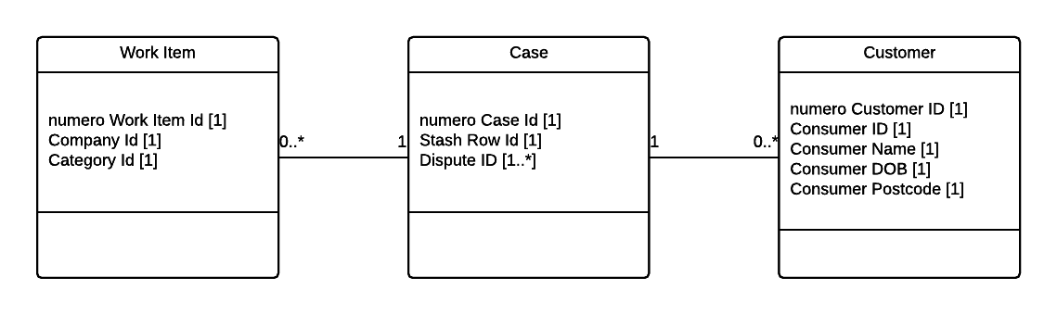

### Internal numero interactive data relationships

A workitem exists within a single case and a case exists with a single customer record.

A customer can contain zero to many cases and a case can contain zero to many workitems. Typically a customer record would contain at least one case and a case would contain at least one workitem but due to the built-in functionality to move work items/cases or the process of archiving workitems/case could result in empty cases/customers.

## Dispute Case Data

The Dispute case data is modelled in the Stash platform component.

### Consumer Data

The following consumer data is stored:

* Consumer Id
* Consumer Name
  + Title
  + Forename
  + Surname
* Current Address
  + Abode
  + House Name
  + House Number
  + Street 1
  + Street 2
  + Town
  + Post code
* Previous Address
  + Abode
  + House Name
  + House Number
  + Street 1
  + Street 2
  + Town
  + Post code
* Contact Preference
* Email address
* Correspondence address

### Dispute Data

* Consumer Id
* Dispute Id
* Dispute Type Id
* Dispute Request
* Source Id
* Supplier Id
* Dispute Type Data
  + Address Link
    - Residence Id
    - Link Residence Id
    - Source Id
    - Last confirmation date
    - Earliest confirmation date
    - Customer Account
    - From address
    - To address
  + Alias Link
    - Email Alias
    - Alias Id
    - Person Id
    - Person Link Id
    - Customer Account Numbers
    - Alias Account Numbers
    - Customer Addresses
  + Associate Link
    - Assoc Id
    - Person Id
    - Associate Id
    - Disassociate Id
  + CCJ
    - Case Number
    - Court Name
    - Judgment Amount
    - CCJ Status
    - Judgment Date
    - Status Date
    - Trading Name
  + Electoral Roll
    - StartDate
    - End Date
    - Opt Out
    - Rolling
  + Insolvencies
    - Court Id
    - Matter No
    - Matter Year
    - Order Type
    - Discharge Date
    - Order Date
    - Restrictions Type Id
    - Restrictions Start Date
    - Restrictions End Date
    - Trading Name
  + Search
    - Search Reference
    - Organisation Name
    - Unit Name
  + Share/MODA
    - Date
    - Lender Account Number
    - Member Portfolio Id
    - Customer Address

### Dispute Case Data

* Consumer Id
* Dispute Id
* Stash Row Id
* Numero Case ID
* Numero Customer ID
* Case Status
* Case Reason
* Case Outcome
* Created Date
* Last Actioned Date
* Supplier Responses
  + Supplier Id
  + Date Received
  + Outcome
  + Comments
* Case History

## Reference Data

### Supplier Data

* Supplier Id
* Supplier Name
* Supplier Email Address
* Active

### Case States

* Case State Id
* Case State Name
* Active
* User selectable

### Noddle/Reseller Notifications

* Notification Id
* Notification name
* Source Id
* Active

### Rejection Reasons

* Rejection reason Id
* Rejection reason name
* Case State Id
* Template GUID
* Active

### Sources

* Source Id
* Source name
* Active

### Dispute Types

* Dispute Type Id
* Dispute name
* Active

### Alert Schedule

* Alert Schedule Id
* Schedule Name
* Number of Alerts
* Alert Frequency (working hours)
* Supplier Id
* Dispute Type Id
* Effective From Date
* Effective To Date

### Data Update Rules

* Data Update Rule Id
* Data Update Rule Name
* Supplier Id
* Dispute Type Id
* Effective From Date
* Effective To Date

### Exception Rules

* Exception Rule Id
* Rule Name
* Exception Id
* Auto Retry
* Supplier Id
* Dispute Type Id
* Effective From Date
* Effective To Date

### Auto Processing Rules

* Auto Processing Rule Id
* Auto Processing Name
* Supplier Id
* Dispute Type Id
* Effective From Date
* Effective To Date

### Validation Rules

* Validation Rule Id
* Validation Rule Name
* Supplier Id
* Dispute Type Id
* Effective From Date
* Effective To Date

### SLA Schedule

* SLA Schedule Id
* SLA Schedule Name
* Dispute Type Id
* SLA (elapsed Days)

# Dispute Processes

## Overview

The diagram below provides an overview the numero managed processes and the interactions between those processes for the Disputes solution.

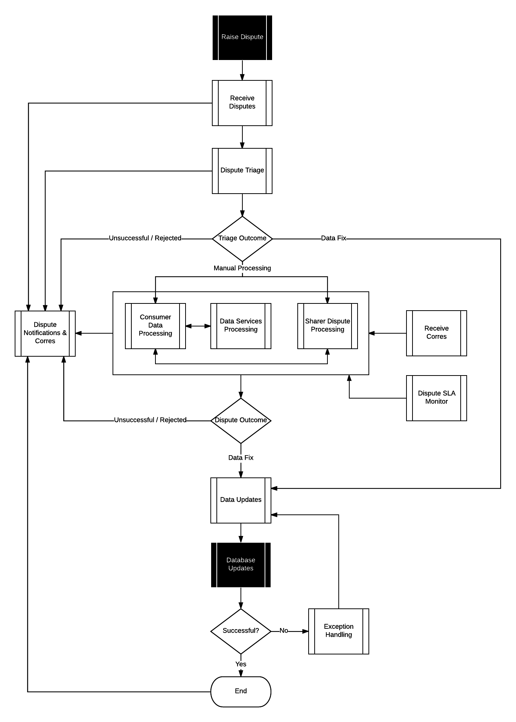

## State Model

The diagram below details the process steps and associated state changes through the Dispute case handling process.

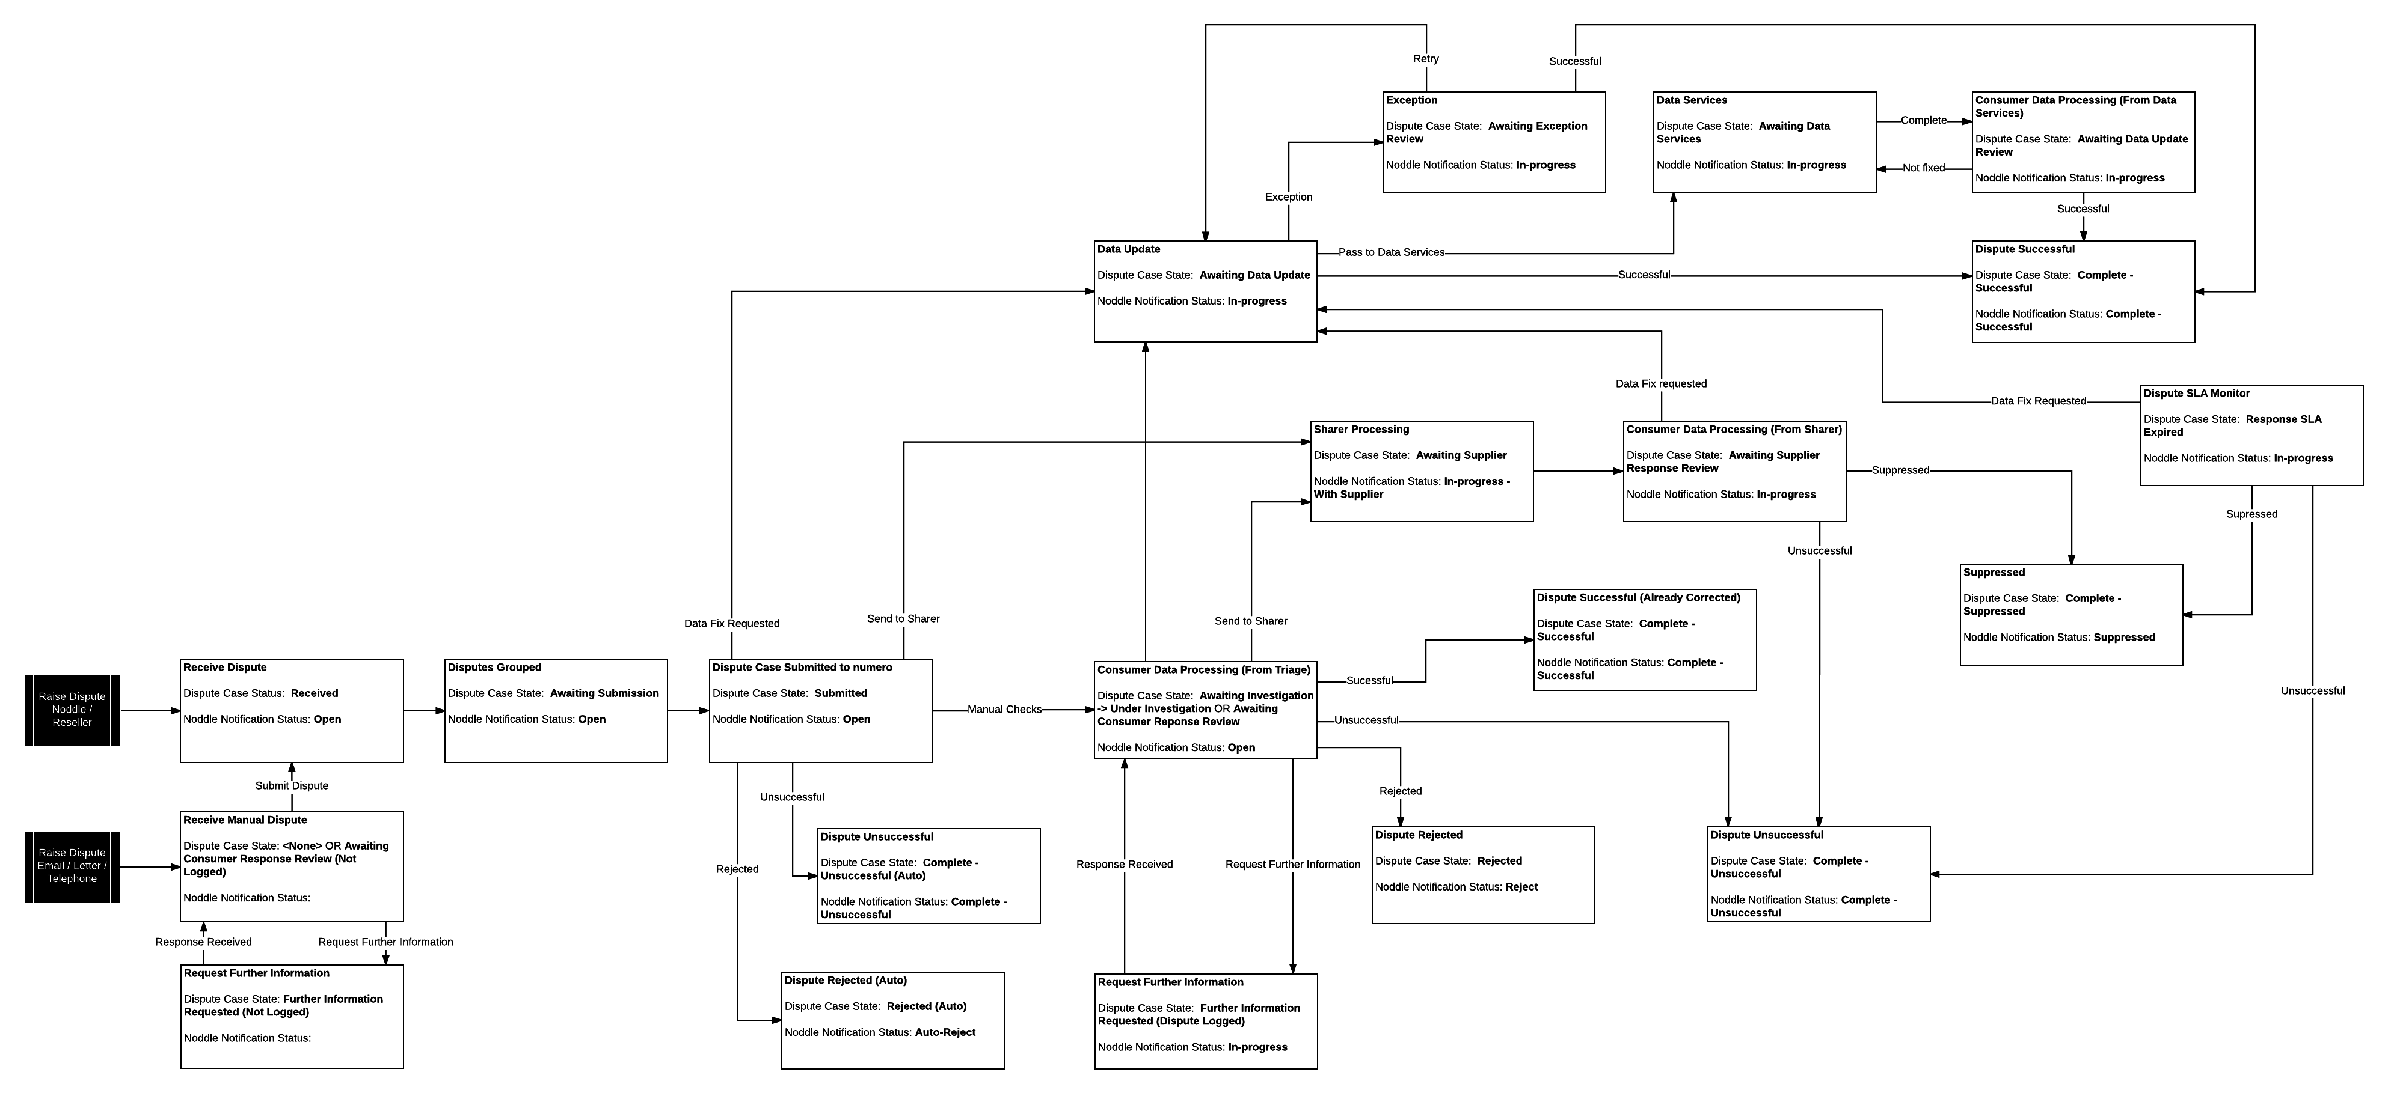

## Receive Dispute

All Disputes cases are received through the Receive Dispute process. The process is detailed in the diagram below.

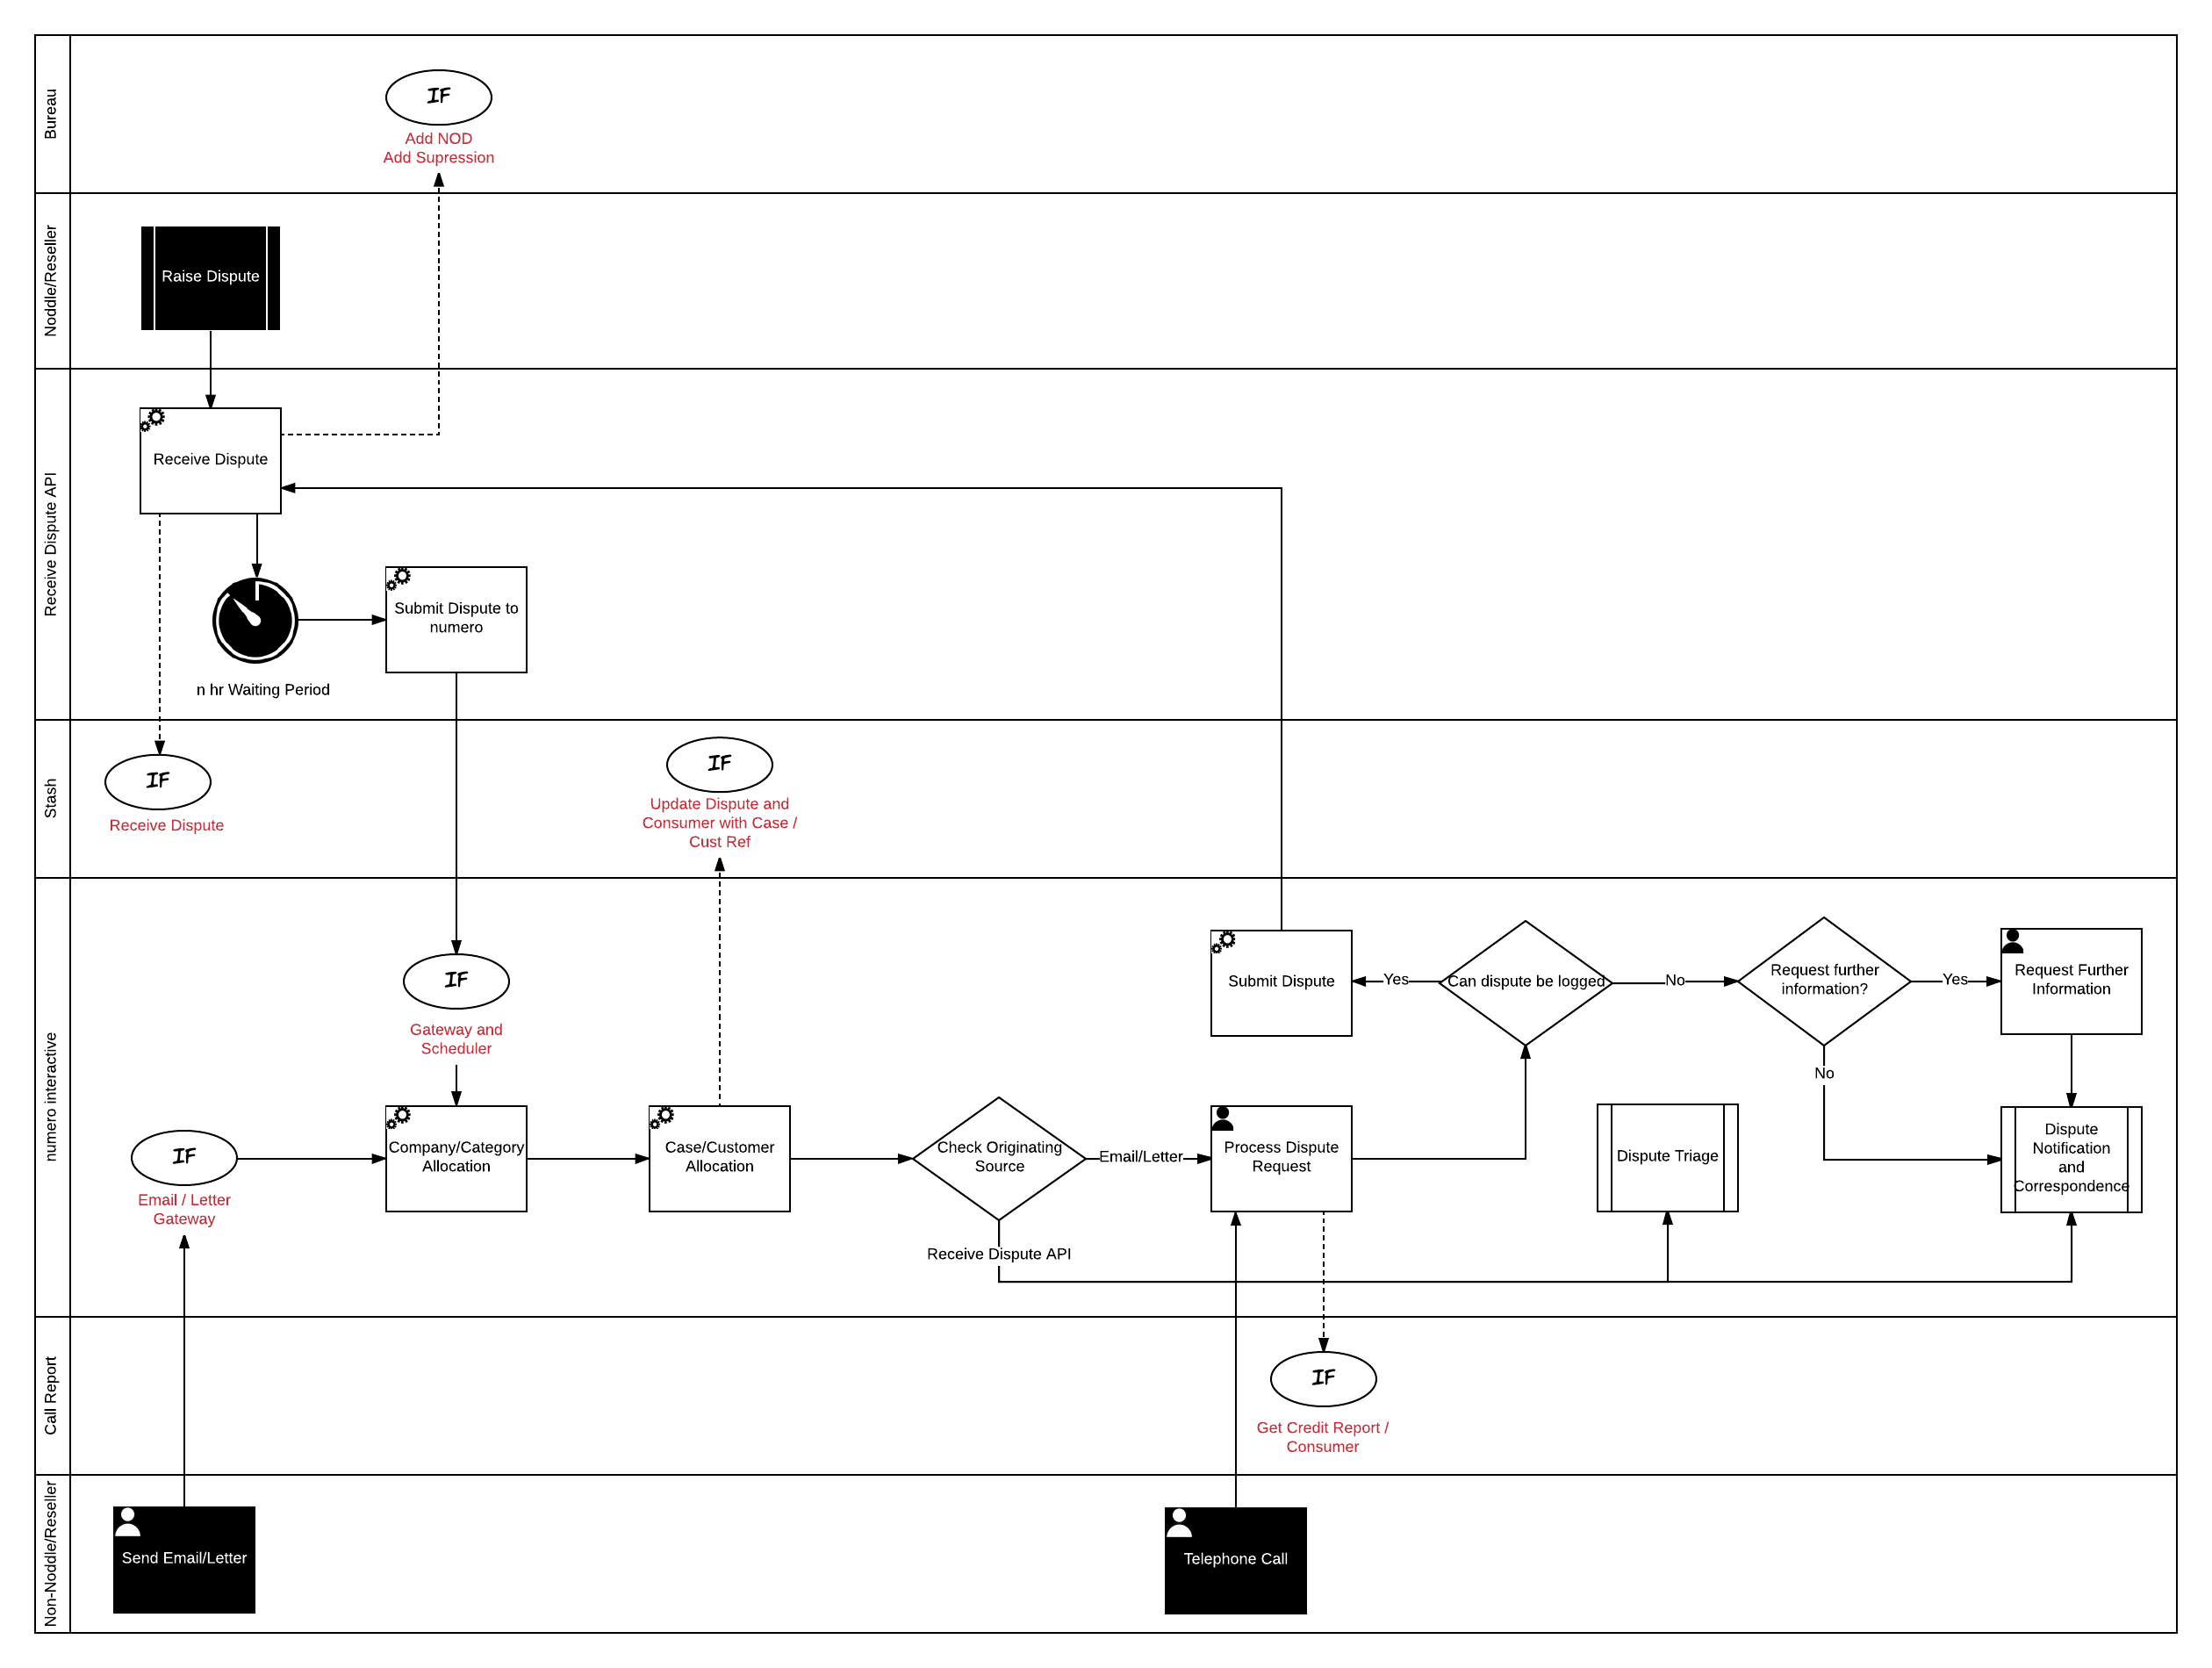

### Receive Dispute

All disputes raised via Noddle or a Reseller are submitted via the Receive Dispute API. On receipt of a Dispute, the following actions are performed:

|  |  |
| --- | --- |
| Action | Detail |
| Add Notice of Dispute (NoD) | In order to comply with GDPR a NOD must be added to the disputed line item. |
| Supress credit report line item | In order to comply with GDPR the disputed line item must be supressed. |
| Save Dispute case | All dispute case data is mastered in the Stash numero platform component. |
| Group Dispute cases |  |
| Start grouping timer | Numero groups dispute cases raised by a consumer within n hours where n is configurable. |

**Note:** Dispute cases are not submitted to and created within the numero console until the grouping timer has expired. This prevents creating unnecessary cases and the overhead of automatically managing numero cases in the event disputes are grouped together.

### Submit Dispute to numero

Once the grouping period has elapsed the Consumer Disputes are submitted into numero via a numero inbound gateway.

The number of workitems submitted and subsequently the number of numero cases created is determined by the volume of grouped Disputes created for the Consumer during the Receive Disputes process.

|  |  |
| --- | --- |
| Case Relationship | Details |
| Single numero case | One case is created if the Consumer has raised a single Dispute regarding an individual credit report line item. |
| Single numero case | One case is created if the Consumer has raised a multiple Disputes regarding a single credit report line item. |
| Multiple numero cases | Multiple numero cases are created if a Consumer has raised multiple Disputes regarding multiple credit report line items. |

### Company / Category Allocation

Each workitem submitted to numero is enriched with the relevant Company and Category enabling it to be routed to the correct team.

The following companies are configured within numero:

* Noddle
* Reseller
* Other

The company is set using the following rules:

|  |  |
| --- | --- |
| Channel | Rule |
| Noddle/Reseller | Source of Dispute |
| Email | ‘To’ email address |
| Letter | Source as set in the meta data OR manual agent selection |
| Phone | Manual agent selection |

**Note:** The company defaults to ‘Noddle’ if a rule isn’t matched. It is the handling agent’s responsibility to ensure the company has been set correctly.

The following categories are configured within numero:

* Address Links
* Alias Links
* Associate Links
* Public
* Share
* Search
* MODA
* Dispute Enquiry

The category is set using the following rules:

|  |  |
| --- | --- |
| Channel | Rule |
| Noddle/Reseller | Dispute type |
| Email | Always set to Dispute Enquiry. The disputes logged from the Email are set using the information captured by the agent when logging the Dispute(s). |
| Letter | Always set to Dispute Enquiry. The disputes logged from the Letter are set using the information captured by the agent when logging the Dispute(s). |
| Phone | Always set to Dispute Enquiry. The disputes logged from the Phone are set using the information captured by the agent when logging the Dispute(s). |

### Case and Customer Allocation

All non-telephony inbound Disputes are automatically linked to a numero case and customer.

* If a numero case reference is extracted the workitem is linked to that customer and case combination.
* The Consumer Id is provided from Noddle/Reseller or if a Consumer Id is returned from the Call Report searches, and a numero customer with that Consumer Id exists, the workitem is linked to a new case against the existing numero customer record.
* The Consumer Id is provided from Noddle/Reseller or if a Consumer Id is returned from the Call Report searches, and a numero customer with that Consumer Id does not exist, the workitem is linked to a new case against a new numero customer record.
* The Consumer Id is not provided from Noddle/Reseller or if a Consumer Id is not returned from the Call Report searches the workitem is linked to a new case against a new numero customer record. Once the Consumer Id has been identified by the agent the numero customer record is updated with the Consumer Id.

Telephone workitems are manually linked to a numero case and customer by the handling agent.

### Check originating source

Once the enrichment processes have been complete if the Dispute was raised via Noddle or a Reseller it is passed into Dispute Triage for further processing.

### Work Allocation

Disputes raised via Email, letter and Telephone have to be processed and logged by an Agent. The numero resource manager manages the queues and determines when to pop the workitem to an available agent.

Dispute Case workitems are allocated based on category (Dispute Type) as detailed in section Work Distribution.

### Process Dispute Request

When the workitem is popped to an agent. The agent is responsible for investigating and determining the next steps for the Dispute Case. To support the investigation the agent is presented with the Log Dispute data form. This form provides access to the data and features required to log the case. The form is detailed in section Log Dispute.

Logging a manual Dispute is performed in a few steps within numero interactive:

* Manually search for the Consumer if we have not been able to identify them from data contained within the Email or Letter.
* Link the Consumer record to an existing numero Case and Customer, or create a new Case and Customer if appropriate.
* View the Credit Report within numero to identify and select the items to be disputed.

The table below details the potential outcomes from processing the Dispute Request.

|  |  |
| --- | --- |
| Outcome | Detail |
| Wrap/Close | If the agent determines the Dispute case cannot be logged the workitem is closed. |
| Abandon | Used when handling a telephone call to abandon the logging in the event the caller hangs up. |
| Escalate | Escalate the logging process to a Team Leader. |
| Request Further Information | The Agent does not have enough information to log the Dispute.  The agent sends an outbound correspondence to the relevant party requesting the information. See section Request Further Information. |
| Log Dispute | The Dispute(s) are logged via the Receive Dispute API layer. |

### Submit Dispute

If the information received via Letter or Email is sufficient enough to allow the Agent to submit the manually created Dispute, then it will be sent into the Receive Dispute process via the Receive Dispute API. This approach ensures that all Disputes, regardless of how they were logged, are subject to the same processing, in particular the grouping rules providing consistency and further reducing potential duplication.

### Request Further Information

If the Agent does not have enough information to submit the Dispute they may have to request further information from the Consumer. This will generate outbound correspondence via email or letter, depending on the Consumer preferences (if we have been able to determine it). If no preference information is available then the Agent will use the same channel as the inbound work item.

The Agent will then close down the work item activity, the Dispute Case will only progress once we receive the requested information from the Consumer.

## Dispute Triage

Once Disputes have been logged via the Receive Disputes process the Dispute case is routed to the Dispute Triage process. The process is detailed in the diagram below.

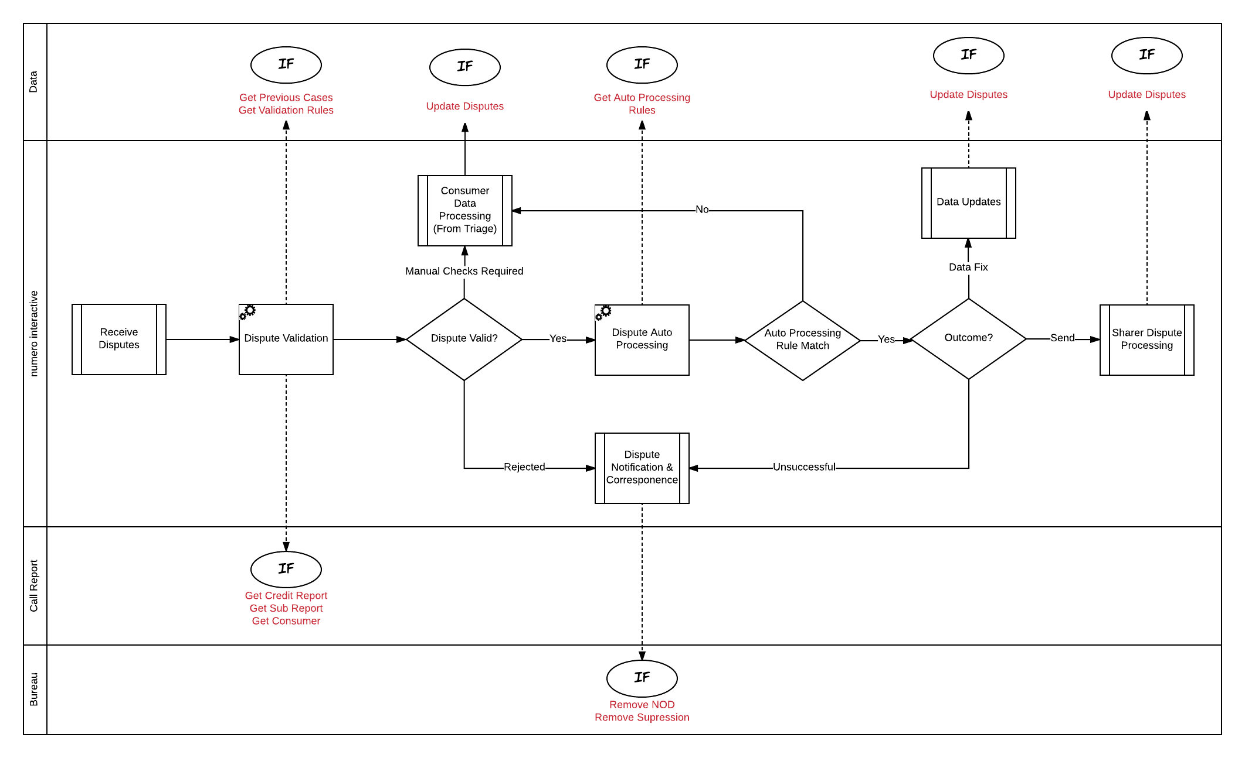

### Dispute Validation

The first step within the Triage process is to obtain various sources of information that will enable numero to make an informed decision on the validity of the Dispute. The following information is required:

* Credit Report and Sub Report Data
* Consumer Data
* Previous Dispute Cases

The following rules are configured to determine the validity of the Dispute:

|  |  |
| --- | --- |
| Rule | Details |
| Required data available | If the Dispute case does not have all of the mandatory Dispute data the case is rejected. |
| Dispute date | If the dispute has been raised before the last update date Dispute case is routed for manual processing. |
| Duplicate checks | If the consumer has previously raised a Dispute against the same line item, within a specified time period, the dispute is rejected. |

Where numero flags a potentially validity issue but cannot make a final decision the case is routed to Consumer Data Processing for review. See section Consumer Data Processing From Triage.

If the validation check sets the case as invalid, the Dispute is rejected and appropriate notifications sent to Noddle and the Consumer and the NOD and Suppression removed. See section Dispute Notifications & Correspondence.

### Dispute Auto Processing

If the Dispute is valid numero attempts to auto-process the Dispute. The automation is executed against pre-defined Auto Processing Rules as detailed below:

|  |  |
| --- | --- |
| Auto Processing Rule | Details |
| Consumer Name and Date of Birth checks | This rule is applied to all Dispute cases.  Check that the Consumer name and Date of Birth as registered on Noddle match the Consumer name and Date of Birth on all credit report line items.  If any differences are found a potential file merge is flagged and the case cannot be auto processed. Consumer Data Processing for review. See section Consumer Data Processing From Triage. |
| Address Link | Address Link disputes can be auto processed:  If the link is created by Callcredit or Eurodirect  AND  If no share or public data exists under the link  AND  If only one address link is disputed at the end of an address chain.  THEN  Send to Data Update. See section Data Updates.  ELSE  If single source pass to Supplier. See section Supplier Dispute Processing.  ELSE  Route to Consumer Data Processing for review. See section Consumer Data Processing From Triage. |
| Alias Link | Alias Link disputes can be auto processed:  If the link is created by Callcredit or Eurodirect  THEN  Send to Data Update. See section Data Updates.  ELSE  If single source pass to Supplier. See section Supplier Dispute Processing.  ELSE  Route to Consumer Data Processing for review. See section Consumer Data Processing From Triage. |
| Associate Link | Associate Link disputes can be auto processed:  If there is no active joint accounts with the associate  OR  If the associate is deceased  THEN  Send to Data Update. See section Data Updates.  ELSE  Route to Consumer Data Processing for review. See section Consumer Data Processing From Triage. |
| Search | Search disputes can be auto processed:  If search created by Callcredit  AND  If the unit name is “Callcredit Noddle (HDD)”  AND  If the Consumer doesn't have Noddle Account.  THEN  Send to Data Update. See section Data Updates.  ELSE  Auto route to Supplier. See section Supplier Dispute Processing. |
| Share/MODA | All Share/Moda disputes are routed to the Supplier. See section Supplier Dispute Processing. |
| Public Data | No auto processing rules. |

**Note:** There are currently no auto processing rules that constitute an Unsuccessful Dispute. However this might be used in the future for certain Dispute types and provision made in the rules to allow for this routing

## Consumer Data Processing From Triage

If it has not been possible to automatically process the Dispute during Dispute Triage the case is routed to an agent in the Consumer Data Processing team to handle. The process is detailed in the diagram below.

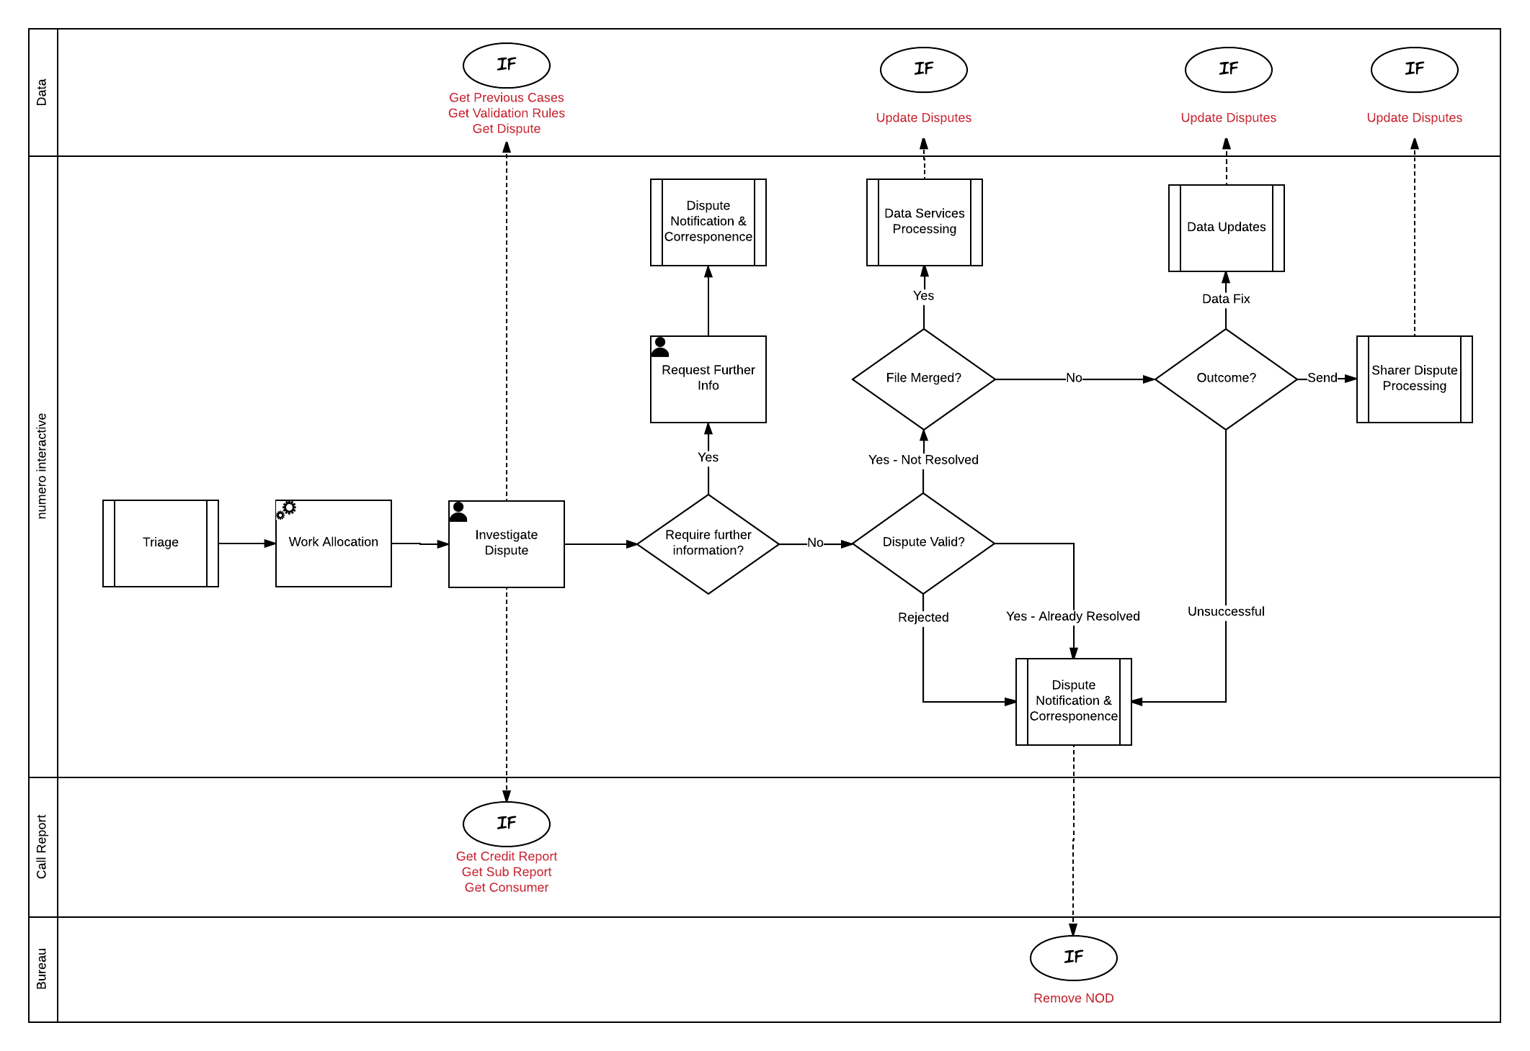

### Work Allocation

If a case requires manual processing following triage a workitem is spawned and queued. The numero resource manager manages the queues and determines when to pop the workitem to an available agent.

Dispute Case workitems are allocated based on category (Dispute Type) as detailed in section Work Distribution.

### Investigate Dispute

When the workitem is popped the agent is responsible for investigating and determining the next steps for the Dispute Case. To support the investigation the agent is presented with the Dispute Case data form. This form provides access to the data and features required to progress the case. The form is detailed in section Dispute Case Home

During the investigation the agent is attempting to complete the required questions in the Case Actioning section in order to drive the next case action. The decision trees are described in section Case Actioning.

The table below details the potential outcomes from the investigation, driven by the case actioning responses.

|  |  |
| --- | --- |
| Outcome | Detail |
| Request further information | The Agent does not have enough information to investigate the dispute or the required evidence has not been submitted.  The agent sends an outbound correspondence to the relevant party requesting the information. See section Request Further Information.  The agent completes the workitem using the Complete form. |
| Dispute rejected | The Agent rejects the Dispute based on the rules described in section Dispute Validation.  The agent completes the workitem using the using the Complete form.  The Dispute Notifications and Corres process is invoked to send the Noddle/Reseller notifications (where required) and automatically inform the customer of the outcome.  The NOD and Suppression is removed. |
| Dispute successful | The Agent determines the Dispute is successful but identifies that the correction has been made after the Dispute case was raised.  The agent completes the workitem using the Complete form.  The Dispute Notifications and Corres process is invoked to send the Noddle/Reseller notifications (where required) and automatically inform the customer of the outcome.  The NOD and Suppression is removed. |
| File merge identified | The Agent determines a file separation is required.  The Agent submits the file separation request to Data Services Processing using the File Merge Request form and the workitem is completed. |
| Dispute unsuccessful | The Agent determines that the Dispute cannot be addressed and therefore has been unsuccessful.  The agent completes the workitem using the Complete form.  The Dispute Notifications and Corres process is invoked to send the Noddle/Reseller notifications (where required) and automatically inform the customer of the outcome.  The NOD and Suppression is removed. |
| Data fix requested | The Agent has determined that a data fix is required.  The Agent submits the dispute the Data Updates process using the Data Update Request form and the workitem is completed. |
| Dispute sent to supplier(s) | The Agent determines the Dispute case needs to be passed to the supplier(s) for resolution.  The Agent passes the Dispute case to Supplier Dispute Processing using the Send to Suppliers form and the workitem is completed. |

### Request Further Information

If the during the investigation the agent determines that additional information, such as Evidence for Public Disputes, is required a manual outbound response is created to request the information.

Outbound communications are composed and sent using numero interactive’s response editor. The editor provides access to templates and suggested content to assist in the creation of the outbound communication.

All outbound communications are sent via the Notification and Correspondence process detailed in section Dispute Notifications & Correspondence.

## Consumer Data Processing From Supplier

When all of the suppliers have responded to a Dispute case or if the Dispute SLA Monitor process has been invoked, the Consumer Data Processing Team are required to review the response(s)/no response(s) and action the case accordingly. The process is detailed in the diagram below.

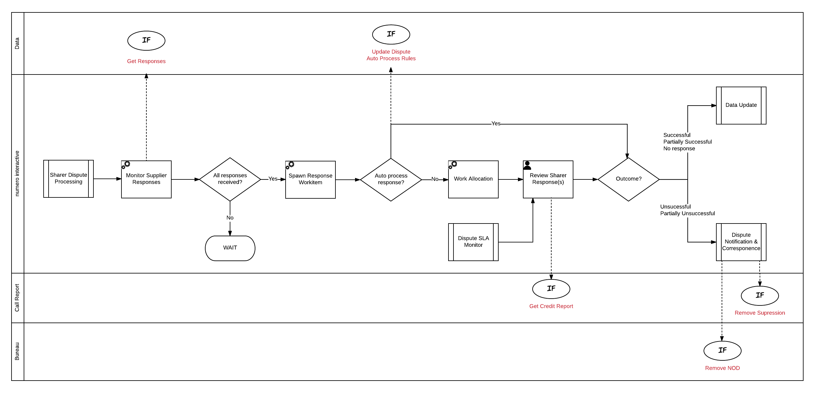

### Monitor Supplier Responses

An agent can only process a Dispute case once all of the Suppliers have responded. When a supplier responds using the Supplier Portal the Monitor Supplier Responses process checks if all responses have now been received.

**Note:** It is assumed all supplier responses are received via the Supplier Portal. There is no provision in the design to manually log supplier responses.

### Spawn Response Workitem

When all response have been received a workitem is spawned in numero to process the Dispute case.

### Auto process response?

Where possible, numero will attempt to auto process the Dispute case based on the response(s). Auto processing is possible for following responses:

|  |  |
| --- | --- |
| Responses | Detail |
| Yes - All rejected | The Dispute Notifications and Correspondence process is invoked to send the Noddle/Reseller notifications (where required) and automatically inform the customer of the outcome. |
| Yes - Accepted (Share/MODA) | The case is routed to the Data Updates process to supress the account information. |

All other combinations of responses are routed to Consumer Data Processing to review.

**Note:** Further auto processing rules to be defined during build.

### Work Allocation

If the case cannot be auto processed the workitem is queued. The numero resource manager manages the queues and determines when to pop the workitem to an available agent.

Dispute Case workitems are allocated based on category (Dispute Type) as detailed in section Work Distribution.

### Review Supplier Responses

When the workitem is popped the agent is responsible for reviewing the supplier responses and determining the next steps for the Dispute Case. To support the review the agent is presented with the Dispute Case Home Supplier Response data form. This form provides access to the data and features required to progress the case following the supplier responses or the Dispute SLA Monitor process having been invoked. The form is detailed in section Dispute Case Home Supplier Response.

During the review the agent is attempting to complete the required questions in the Case Actioning section in order to drive the next case action. The decision trees for checking Supplier responses are described in section Check Supplier Responses*.*

The table below details the potential outcomes from the review, driven by the case actioning responses.

|  |  |
| --- | --- |
| Outcome | Detail |
| All successful | If all of the suppliers have responded and accepted the Dispute the Agent submits the dispute to the Data Updates process using the Data Update Request form and the workitem is closed. |
| Partially successful | If a subset of the suppliers have responded and accepted the Dispute the Agent submits the dispute to the Data Updates process to update the data for those suppliers using the Data Update Request form where required and the NOD and suppression (where applicable) are removed. For suppliers who have not responded a request to suppress the line item is submitted and the NOD removed.  The Dispute Notifications and Corres process is invoked to send the Noddle/Reseller notifications (where required) and automatically inform the customer of the outcome. |
| No response | If all or a subset of the suppliers have failed to respond the Dispute the Agent submits the dispute to the Data Updates process to update the data for those suppliers using the Data Update Request form and the workitem closed.  The NOD is removed and the line item suppressed. |
| All unsuccessful | The agent completes the workitem the using the Complete form.  The Dispute Notifications and Corres process is invoked to send the Noddle/Reseller notifications (where required) and automatically inform the customer of the outcome.  The NOD and suppression (where applicable) are removed. |
| Partially unsuccessful | If a subset of the suppliers have responded and rejected the Dispute the agent completes the workitem the using the Complete form.  The Dispute Notifications and Corres process is invoked to send the Noddle/Reseller notifications (where required) and automatically inform the customer of the outcome.  The NOD and suppression (where applicable) are removed. |

## Consumer Data Processing From Data Services

When Data Services confirm the data update is complete the Consumer Data Processing Team are required to review the update and action the case accordingly. The process is detailed in the diagram below.

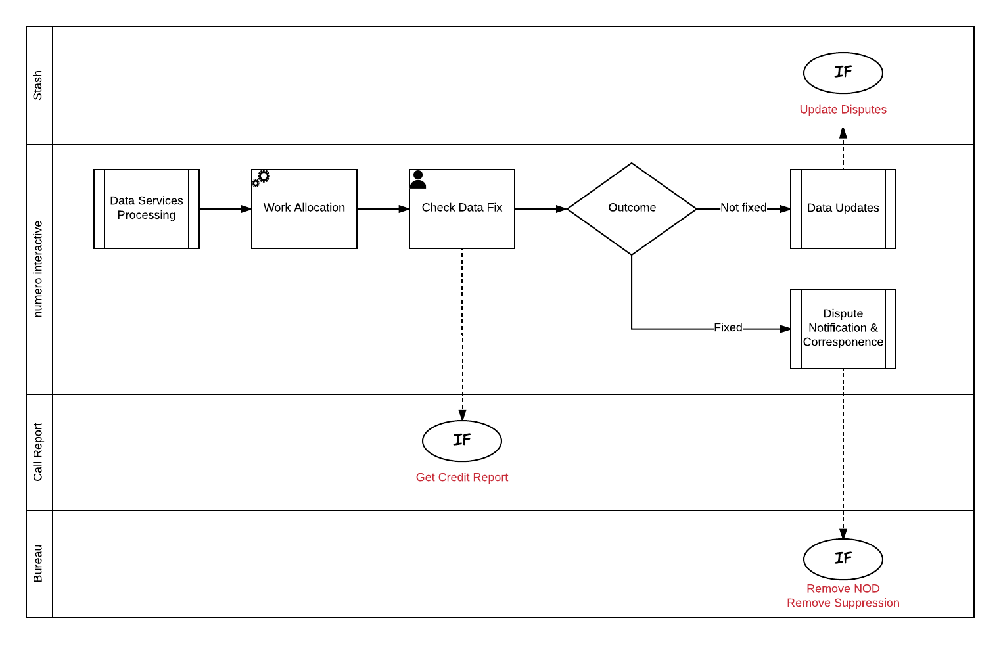

### Work Allocation

When the data fix requires checking a workitem is spawned and queued. The numero resource manager manages the queues and determines when to pop the workitem to an available agent.

Dispute Case workitems are allocated based on category (Dispute Type) as detailed in section Work Distribution.

### Check Data Fix

When the workitem is popped the agent is responsible for checking the data fix and determining the next steps for the Dispute Case. To support the check the agent is presented with the Dispute Case Home data form. This form provides access to the data and features required to progress. The form is detailed in section Dispute Case Home.

The Agent completes the required questions in the Case Actioning section in order to drive the next case action. The decision trees for checking data fixes are described in section Check Data Services Fix*.*

The table below details the outcomes of the check, driven by the case actioning responses.

|  |  |
| --- | --- |
| Outcome | Detail |
| Fixed | The Agent determines the fix is successful.  The agent completes the workitem the using the Complete form.  The Dispute Notifications and Corres process is invoked to send the Noddle/Reseller notifications (where required) and automatically inform the customer of the outcome.  The NOD and suppression (where applicable) are removed. |
| Not Fixed | The Agent has determined that a data fix was not successful.  The Agent resubmits the dispute to the Data Updates process suppliers using the Data Update Request form and the workitem is closed. |

## Data Services Processing

Data Services are required action and check data fixes that cannot be applied automatically. The process is detailed in the diagram below.

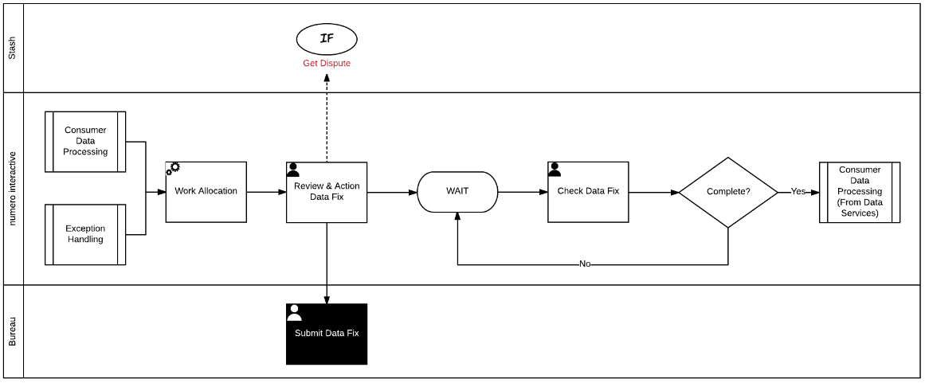

### Work Allocation

When a Dispute case is routed to Data Services a workitem is spawned and queued. The numero resource manager manages the queues and determines when to pop the workitem to an available agent.

Dispute Case workitems are allocated based on category (Dispute Type) as detailed in section Work Distribution.

### Review and Action Data Fix

When the workitem is popped the agent is responsible for reviewing and submitting the Data Fix request. To support the activity the agent is presented with the Data Services Case Home data form. This form provides access to the data and features required to progress. The form is detailed in section Data Services Case Home.

The Agent confirms the Data Update has been requested. The workitem is automatically pended for the next day and queued to support the data fix check.

### Check Data Fix

Data Services Agents are responsible for confirming the data update has completed successfully. The workitem pended from the Action Fix step pops to an appropriate agent next working day after the fix was submitted. If the fix has been applied the Agent confirms the fix and the case is routed to Consumer Data Processing (From Data Services) to confirm the fix. See section Consumer Data Processing From Data Services.

If the fix has not yet been applied the Agent confirms the fix has not been applied and the workitem pended for the next day.

**Note:** It is currently assumed checking the fix is a manual process. However, it may be possible to automate this by extending the exception handling processes.

## Supplier Dispute Processing

Suppliers are responsible for investigating and resolving Dispute cases for which they are the source of the data. When a case is passed to a Supplier numero is responsible for notifying, chasing and receiving the supplier responses. The process is detailed below.

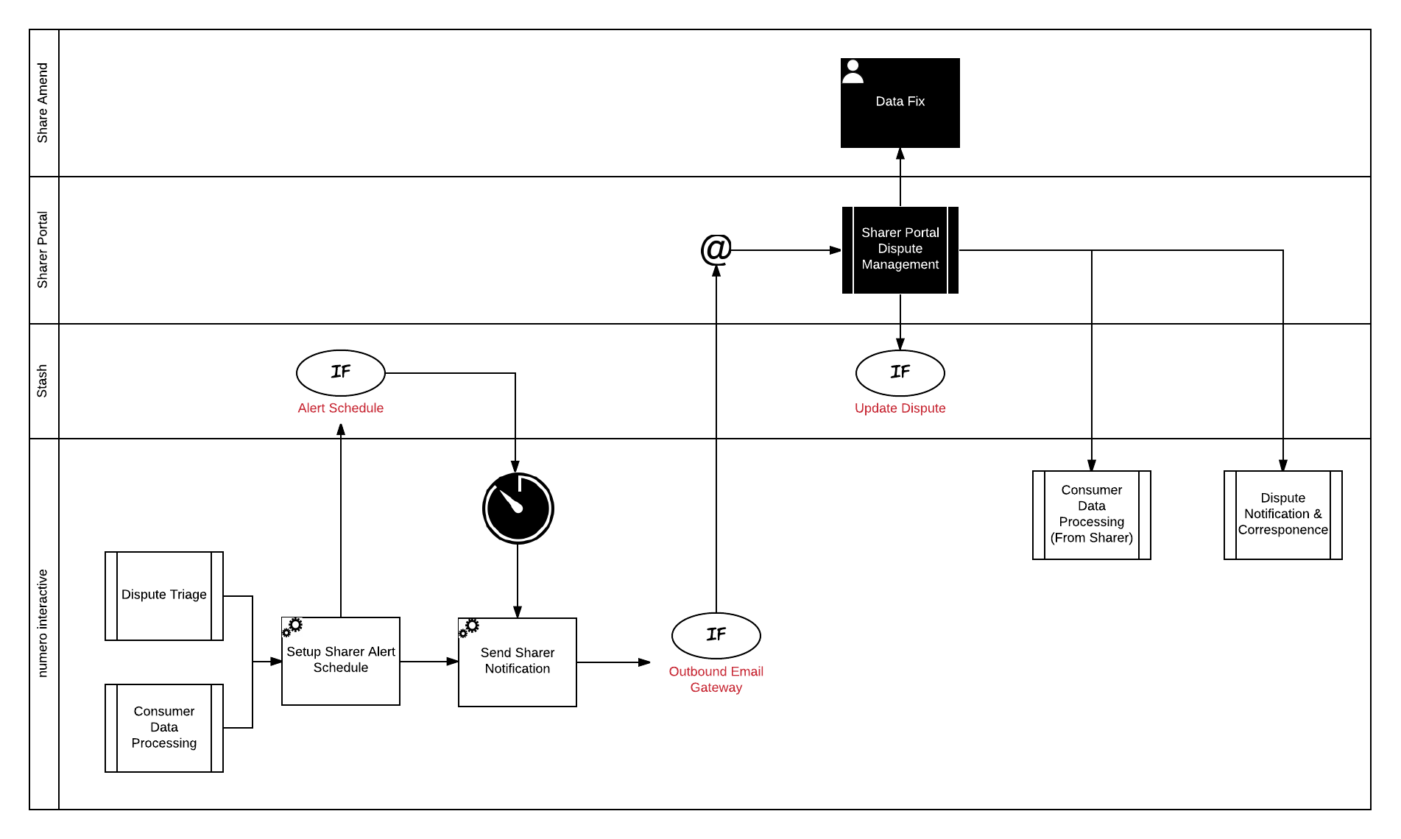

### Setup Supplier Alert Schedule

In order to try and resolve Dispute Cases as quickly as possible numero automatically chases suppliers for a response. When a case is passed to a Supplier an alert schedule is setup for the case that determines when, and how many, automated chasers are sent to the supplier.

### Send Supplier Notification

When a case is initially passed to a supplier, or when an alert is generated, an outbound email is sent to the supplier informing them a Dispute case is awaiting their review. The email contains a link to the Dispute case within the Supplier Portal.

### Supplier Portal Dispute Management

The Supplier Portal Dispute Management processes are described in the Supplier Portal SDD.

When a supplier provides an outcome to the Dispute the case is routed back to the Consumer Data Processing team for review. See section Consumer Data Processing From Supplier

## Data Updates

The Data Update process is an automated process that manages the different types of data fix requests and actions according. The process is detailed below.

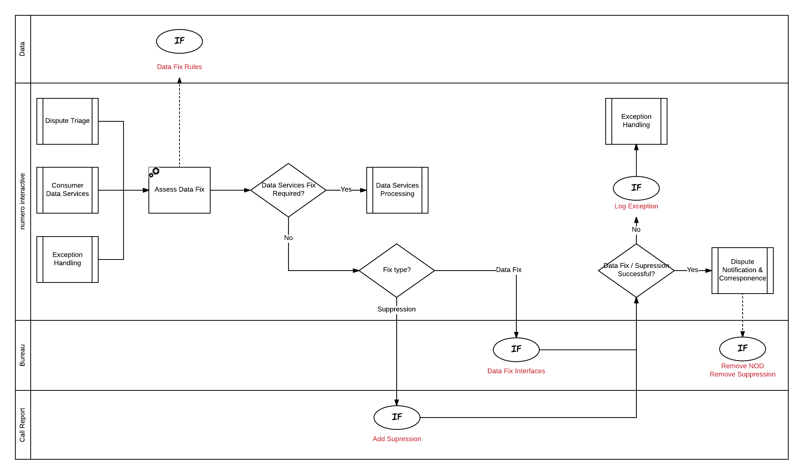

### Asses Data Fix

When a Dispute Case is sent for data update, numero assesses the requested fix to determine how the fix should be applied. The assessment uses Dispute case data and the results from the Case Actioning questions to determine where to route the case.

If the data fix has to be applied by Data Services the case is routed to the Data Services Processing workflow as described in section Data Services Processing.

The assessment rules are as follows:

|  |  |
| --- | --- |
| Assessment Rule | Details |
| File merge | If the agent has marked this case as file merge it is routed directly to Data Services. |
| Person move | If the agent has marked the case as person move it is routed directly to Data Services. |
| Data Services Required | If the agent has marked the case as Data Services Fix required it is routed directly to Data Services. |

### Fix Type?

A Dispute case may require a suppression, data update or both.

Suppression requests are sent to Call Report to add the suppression.

Data Fix requests are made using Bureau Services.

Where both suppression and data fixes are required the requests are made in parallel.

### Data Fix / Suppression Successful?

All requests to apply suppressions or for data fixes are monitored. If the request(s) are successful the Dispute case is completed. A notification is routed to the Consumer and the NOD/Suppression (where applicable) removed. See section Dispute Notifications & Correspondence.

If an exception is received the Dispute case is routed to the Exception Handling process. See section Exception Handling*.*

**Note:** The feedback mechanism is not currently available and needs to be developed as part of this project.

## Exception Handling

If a data update request exception is received numero will determine if the request can be automatically retried. If not, the Consumer Data Processing Team are required to review the exception and action the exception accordingly. The process is detailed in the diagram below.

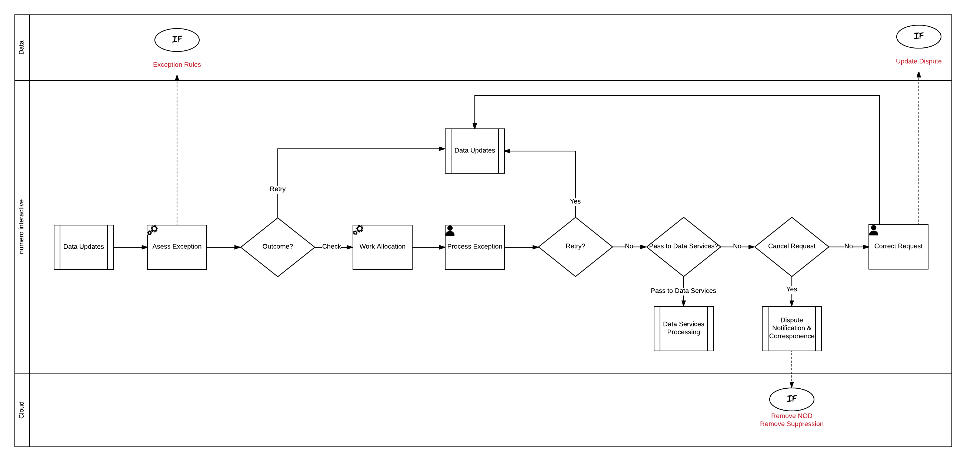

### Assess Exception

When an exception is received numero assess the exception to determine if the request can be automatically submitted.

**Note:** The exception reasons and auto processing rules are to be defined during build.

### Work Allocation

If a case requires manual processing following triage a workitem is spawned and queued. The numero resource manager manages the queues and determines when to pop the workitem to an available agent.

Dispute Case workitems are allocated based on category (Dispute Type) as detailed in section Work Distribution.

### Process Exception

When the workitem is popped the agent is responsible for reviewing the exception and determining the next steps for the Dispute Case. To support the review the agent is presented with the Dispute Case Home Exception Handling data form. This form provides access to the data and features required to progress the case following the exception. The form is detailed in sectionDispute Case Home Exception Handling.

During the review the agent is attempting to complete the required questions in the Case Actioning section in order to drive the next case action. The decision trees for checking exceptions are described in section Exceptions*.*

The table below details the potential outcomes from the review, driven by the case actioning responses.

|  |  |
| --- | --- |
| Outcome | Detail |
| Retry | The agent determines the request can be resubmitted without any amendments.  The Agent resubmits the dispute to the Data Updates process using the Data Update Request form. |
| Edit and Retry | The agent determines the request can be resubmitted with amendments.  The Agent resubmits the dispute to the Data Updates process using the Data Update Request form. |
| Pass to Data Services | The agent determines the request has to be completed by Data Services.  The Agent submits the dispute to the Data Services Team using the Data Update Request form. |
| Cancel | The Agent determines that the data fix is no longer required as the data fix has already been actioned from another source.  The agent completes the workitem using the Complete form.  The Dispute Notifications and Corres process is invoked to send the Noddle/Reseller notifications (where required) and automatically inform the customer of the outcome.  The NOD and Suppression is removed. |

## Dispute SLA Monitor

The Dispute SLA Monitor process is responsible for generating workitems based on Dispute case age. The process is detailed below.

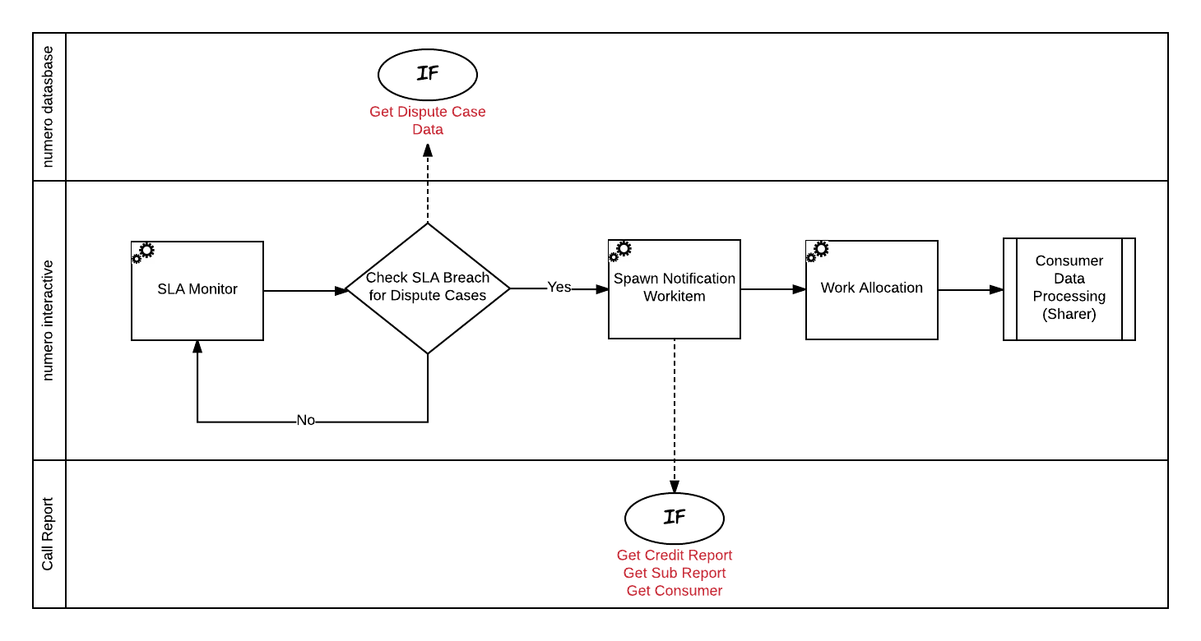

### SLA Monitor

The SLA Monitor is scheduled to run once daily to pick up all cases that are about to breach SLA.

MODA disputes have to be resolved (or suppressed) in 14 days. All other Disputes must be resolved (or suppressed) in 28 days. To ensure these SLAs are met it is recommended that MODA disputes are picked up by the SLA monitor at 10 days and all other disputes are picked up at 24 days.

**Note:** The monitor is configurable and the case age easily amended where required.

### Spawn Work Item Notification

Numero spawns a new workitem for any in-scope Dispute cases. This workitem will contain all relevant Credit, Consumer and Dispute Data.

### Work Allocation

If a case requires manual processing following triage a workitem is spawned and queued. The numero resource manager manages the queues and determines when to pop the workitem to an available agent.

Dispute Case workitems are allocated based on category (Dispute Type) as detailed in section Work Distribution.

### Consumer Data Processing (From Supplier)

The spawned workitem is passed to the Consumer Data Processing (From Supplier) workflow for processing. See section Consumer Data Processing From Supplier.

.

## Receive Correspondence

This process handles all receiving correspondence related to Dispute cases received by either Letter or Email. Typically this is where an agent has requested further information such as evidence or a Supplier is requesting additional information from Callcredit.

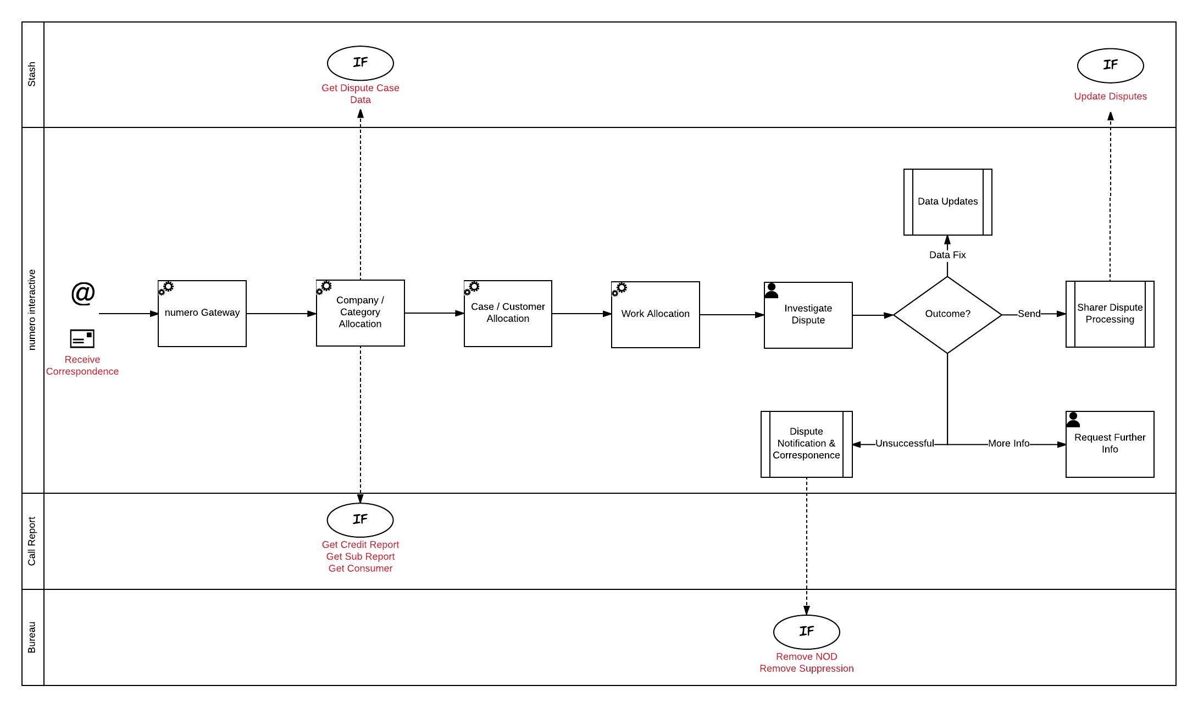

### Numero Gateway

The numero gateway receives Email and Letter correspondence.

### Company / Category Allocation

If the correspondence contains a numero case reference the company and category is inherited from that case.

Where a case reference isn’t identified the rules described in section Company / Category Allocation are used to set the company and category of the workitem*.*

### Case /Customer Allocation

If a numero case reference is extracted the workitem is linked to that case.

Where a case reference isn’t identified the rules described in section Case and Customer Allocation are used to link the workitem to a case and customer.

**Note:** It is the handling agent’s responsibility to ensure the workitem has been linked to the correct case and customer. If the agent identifies the workitem belongs to another case and/or customer they are able to use the standard platform features to move the workitem and/or case.

### Work Allocation

All correspondence received requires manual actioning. The numero resource manager manages the queues and determines when to pop the workitem to an available agent.

Dispute Case workitems are allocated based on category (Dispute Type) as detailed in section Work Distribution.

### Investigate Dispute

When the workitem is popped the agent is responsible for investigating and determining the next steps for the Dispute Case. To support the investigation the agent is presented with the Dispute Case data form. This form provides access to the data and features required to progress the case. The form is detailed in section Dispute Case Home

During the investigation the agent is attempting to complete the required questions in the Case Actioning section in order to drive the next case action. The decision trees are described in section Case Actioning.

The table below details the potential outcomes from the investigation, driven by the case actioning responses.

|  |  |
| --- | --- |
| Outcome | Detail |
| Request further information | The Agent does not have enough information to investigate the dispute or the required evidence has not been submitted.  The agent sends an outbound correspondence to the relevant party requesting the information. See section Request Further Information.  The agent completes the workitem using the Complete form. |
| Dispute rejected | The Agent rejects the Dispute based on the rules described in section Dispute Validation.  The agent completes the workitem using the using the Complete form.  The Dispute Notifications and Corres process is invoked to send the Noddle/Reseller notifications (where required) and automatically inform the customer of the outcome.  The NOD and Suppression is removed. |
| Dispute successful | The Agent determines the Dispute is successful but identifies that the correction has been made after the Dispute case was raised.  The agent completes the workitem using the Complete form.  The Dispute Notifications and Corres process is invoked to send the Noddle/Reseller notifications (where required) and automatically inform the customer of the outcome.  The NOD and Suppression is removed. |
| File merge identified | The Agent determines a file separation is required.  The Agent submits the file separation request to Data Services Processing using the File Merge Request form and the workitem is closed. |
| Dispute unsuccessful | The Agent determines that the Dispute cannot be addressed and therefore has been unsuccessful.  The agent completes the workitem using the Complete form.  The Dispute Notifications and Corres process is invoked to send the Noddle/Reseller notifications (where required) and automatically inform the customer of the outcome.  The NOD and Suppression is removed. |
| Data fix requested | The Agent has determined that a data fix is required.  The Agent submits the dispute the Data Updates process using the Data Update Request form. |
| Dispute sent to supplier(s) | The Agent determines the Dispute case needs to be passed to the supplier(s) for resolution.  The Agent passes the Dispute case to Supplier Dispute Processing using the Send to Suppliers form. |

### Request Further Information

If the during the investigation the agent determines that additional information, such as Evidence for Public Disputes, is required a manual outbound response is created to request the information.

Outbound communications are composed and sent using numero interactive’s response editor. The editor provides access to templates and suggested content to assist in the creation of the outbound communication.

All outbound communications are sent via the Notification and Correspondence process detailed in section Dispute Notifications & Correspondence.

## Dispute Notifications & Correspondence

This process describes the handling of all Noddle/Reseller notifications and outbound correspondence.

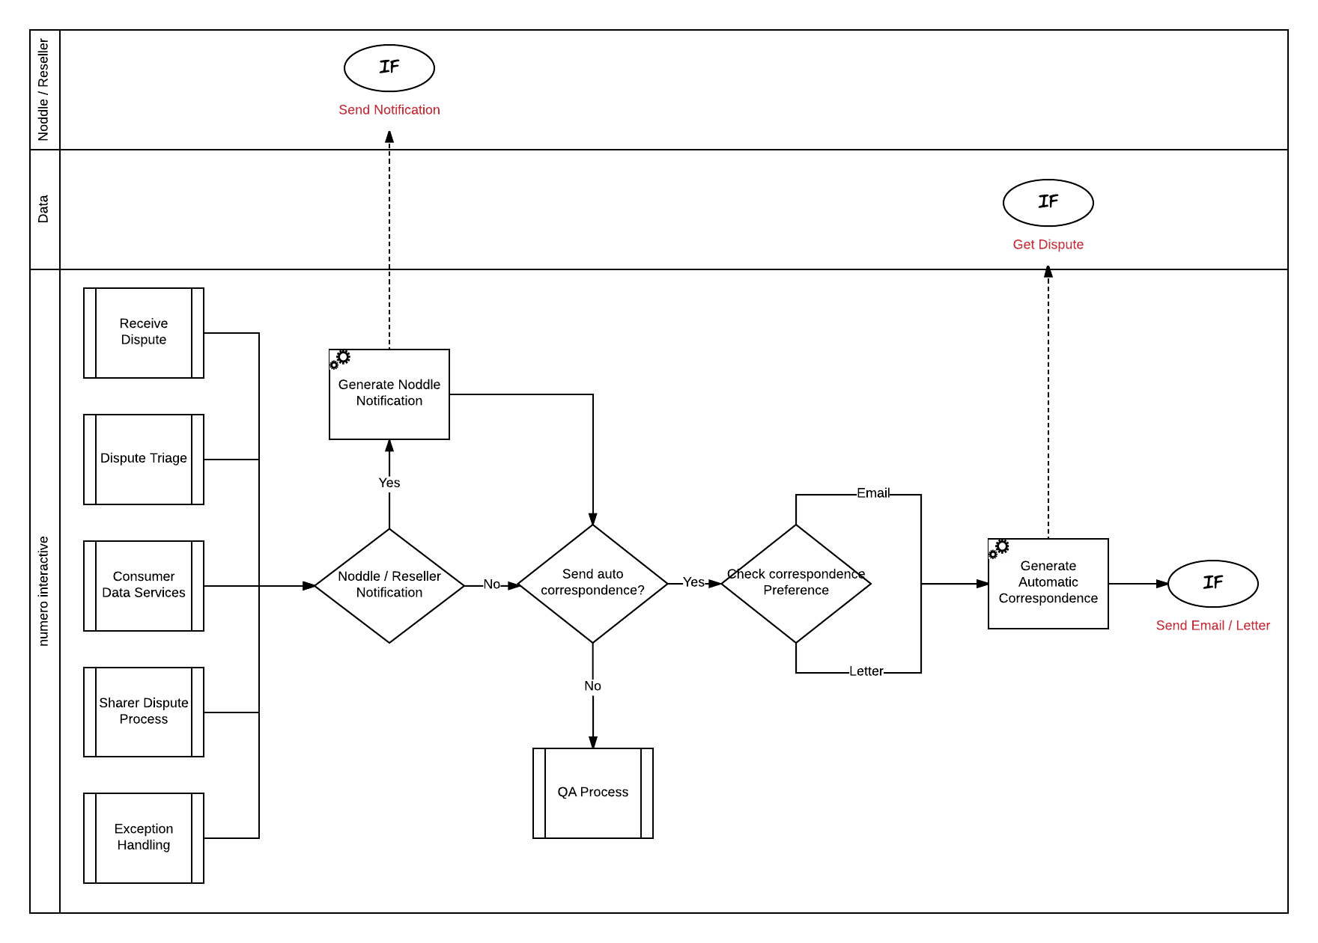

### Generate Noddle Notification

Dependant on the stage of the Dispute case handling it may be necessary to update Noddle / Reseller with the case status. If it is determined a notification is required numero calls the Noddle/Reseller notification API.

The case state model in section State Modelshows the Noddle/Reseller notification status as the case is processed.

### Send Auto Correspondence?

Dependant on the stage of the Dispute case handling it may be necessary to automatically generate outbound correspondence to the Consumer or Supplier.

In addition an Agent may have manually generated a Request for Information email/letter for the Consumer. If a manual outbound email/letter has been generated this overrides any automated notifications.

### Check correspondence preference

If automated correspondence is required numero generates an outbound workitem. If numero has been provided with a Consumers notification preference the selected channel is used.

**Note:** numero recommend pushing all correspondence to email only.

### Generate Automatic Correspondence

Each automatic correspondence is modelled in the numero Content Management System. When sending the correspondence numero uses the Dispute case data to determine the template to use and generates the outbound correspondence using this template.

The email / letter is sent using the numero outbound gateways.

### QA Process

All manually generated correspondence is sent through the QA workflow before being sent.

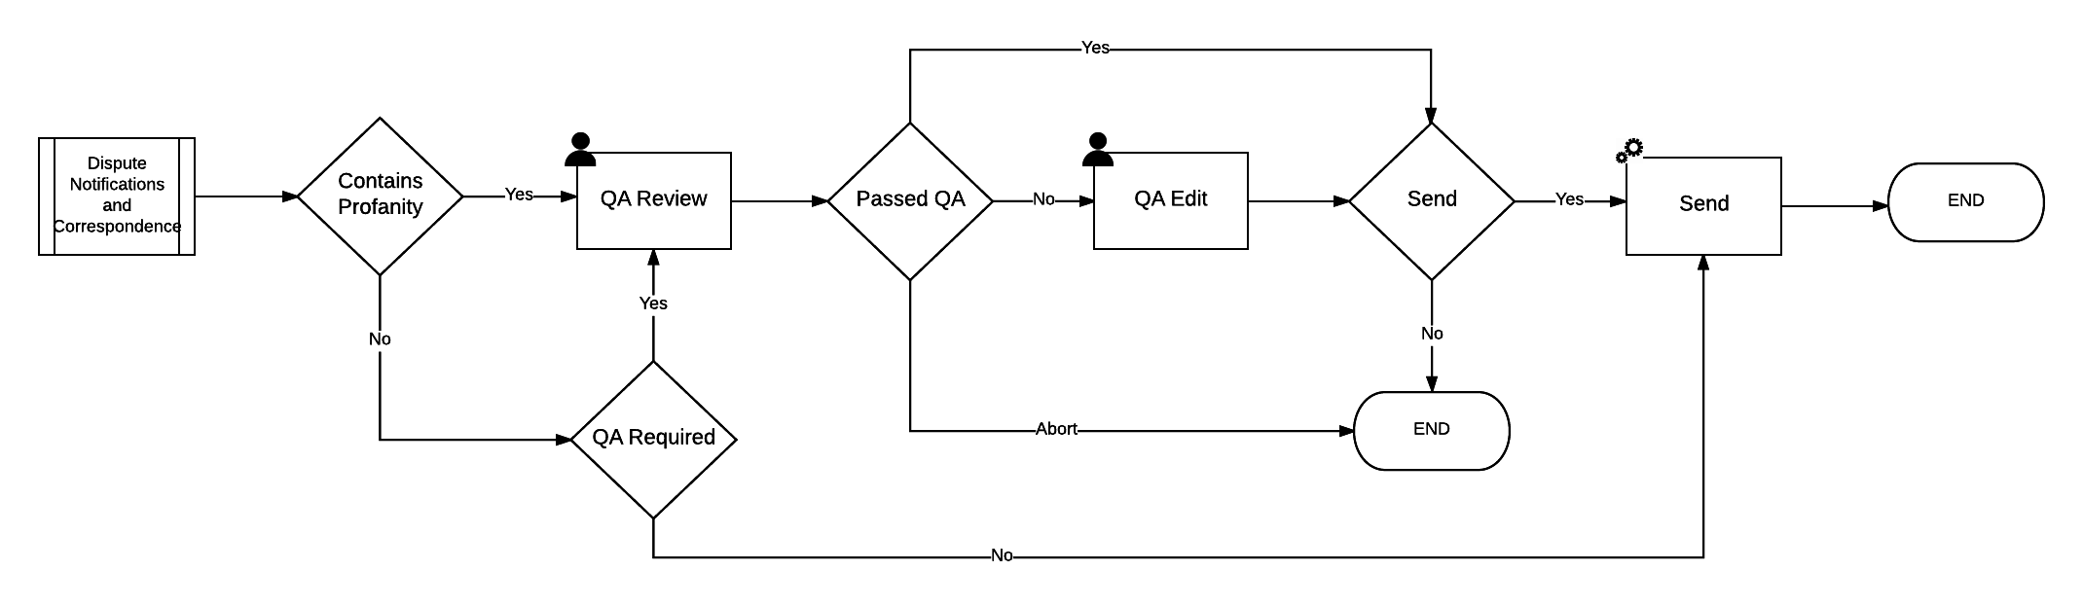

All outbound communications are subject to a check for profane content based on a profanity dictionary.

Dependant on the General Profile assigned to an Agent, a percentage of their outgoing communications may be subject to a QA review before being sent out of numero interactive.

If an outbound communication is sent to QA it is routed to a QA review queue. Typically, a QA Agent will access the work awaiting QA from a query. The QA Agent is able to review the outbound content, make any amendments before sending or abort the send where required. The QA Agent is able to score the quality of the outbound communication which can be used in future performance reviews.

# Dispute Forms

The following wireframes are designed to provide a visual representation of the screens that are used by an agent to manage a Dispute case to completion. They are used to present proposed critical functions, structure, data elements and screen flow in simple terms. They are not intended to provide a detailed final representation of the design but should provide enough information on the key elements of the screens to enable the build work.

## Screen Flow

The diagram below shows the high level flow through the Dispute forms.

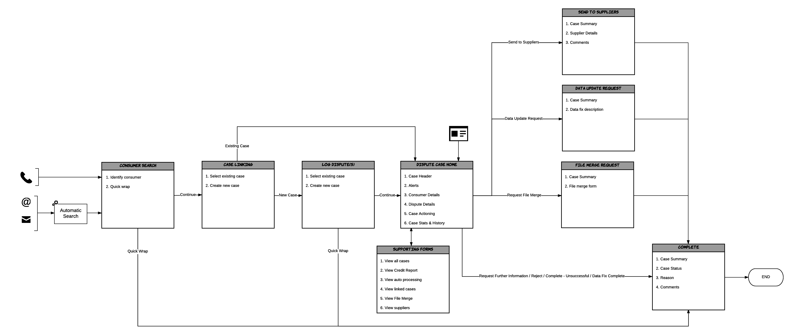

## Log Dispute

The Log Dispute form provides the features and functionality required by an agent to identify a consumer and log a new Dispute case. In addition it allows an agent to link inbound workitems to an existing Dispute case.

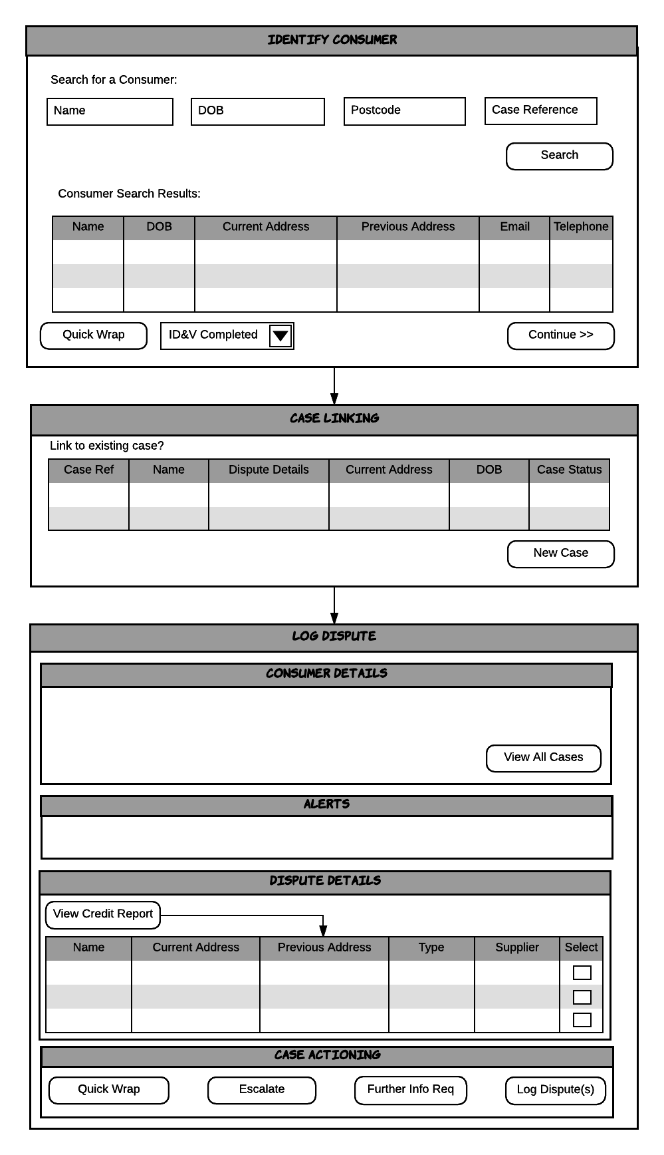

### Identify Consumer

#### Search for a Consumer

When a Dispute is raised via Email, Letter or Telephone the agent must search for the consumer to log the dispute against. For Email and Letters numero will attempt to automatically identify the consumer. If successful the Consumer Search Results grid is populated with the consumer details. If the agent does not agree with the automated search results, the automated search was unsuccessful or when logging a phone call the Dispute agent performs a manual search.

The agent can search for a consumer using all of:

* Name, date of birth and post code

OR

* An existing Dispute case reference.

The results of the search are displayed in the grid, providing enough information for the agent to confirm the correct consumer has been returned.

The agent selects the required Consumer, completes the ID&V field and clicks continue to proceed to the next step.

#### Quick Wrap

The quick wrap feature allows an agent to quickly close the workitem when required, e.g. wrong number.

## Case Linking

Once the consumer has been selected the agent is presented with the case linking dialogue. The grid displays all of the previous numero cases linked to the customer record. If the workitem is related to an ongoing Dispute case the agent can select to link the workitem to that case, otherwise a new Dispute case is created by selecting ‘New Case’.

If linking to an existing Dispute Case the agent is routed to the Dispute Case Home form described in section Dispute Case Home.

### Log Dispute

If a new Dispute case has been created the agent is routed to the Log Dispute form. The Log Dispute form provides all the data and features required to log the Dispute case.

#### Consumer Details

This section shows the following details about the Consumer who has raised the dispute:

* Name
* Date of Birth
* Current Address
* Previous Address
* Contact preferences
* Email address
* Correspondence address

#### Alerts

This section displays key information regarding the case to the handling agent to assist with logging the case or highlighting potential issues that need to be addressed. At the log case step the system may generate the following case alerts:

* Consumer has open dispute cases
* Actionable workitems open in the case

**Note:** This is not an exhaustive list of case alerts. Further alerts will be defined during the build phase.

#### Dispute Details

To log the Dispute the agent views the consumers credit report and marks the line item(s) that the consumer is disputing.

### Case Actioning

The agent has access to the following actions when logging the dispute:

#### Quick Wrap

At any stage the agent can choose to quick wrap the case without completing the Dispute case setup. The Agent provides a reason for choosing to Quick Wrap and the workitem is closed.

#### Escalate

Allows the agent to escalate the case to a colleague or team leader. Selecting this option closes the workitem and pushes it to an escalation queue.

#### Request Further Info

If the consumer has not provided enough information in the Email or Letter the agent may need to request additional information. The Agent creates sends an outbound workitem to the Consumer requesting the information and the workitem is closed.

#### Log Disputes

Once the agent has selected all of the disputed line items they choose to Log Disputes. This sends the disputes into the receive dispute API for processing and completes the workitem.

### Form Usage

* Used within the Receive Dispute Process

## Dispute Case Home

The Dispute Case form provides access to the data and features required to action the case.

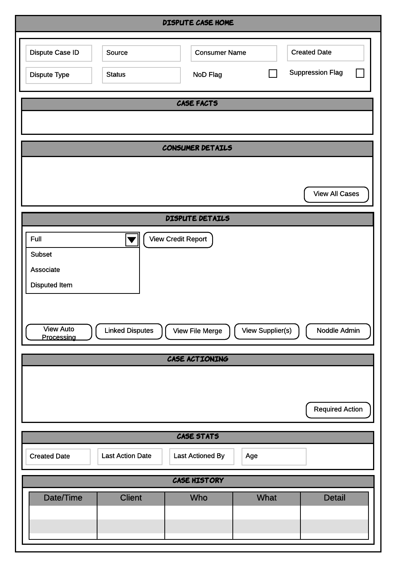

### Case Header

This section provides case summary information. The header is present on all forms used by the handling processes. The header displays the following case information:

* Consumer name
* Dispute source
* Dispute case ID
* Dispute type
* Dispute status
* Dispute creation date
* NoD Flag
* Suppression Flag

### Case Facts

This section displays key information regarding the case to the handling agent to assist with decision making or highlighting potential issues that need to be addressed. The system generates the following case facts:

* Case is out of SLA
* SLA monitor started
* Missing data
* Potential file merge issue
* Linked cases present
* Consumer has open dispute cases
* Actionable workitems open in the case
* Outstanding supplier responses
* All supplier responses received
* Data update exception
* NoD Applied
* Suppression Applied

**Note:** This is not an exhaustive list of case alerts. Further alerts will be defined during the build phase.

### Consumer Details

This section shows the following details about the Consumer who raised the dispute:

* Name
* Date of Birth
* Current Address
* Previous Address
* Contact preferences
* Email address
* Correspondence address

#### View All Cases

View All Cases, accessed from the Consumer Details section, presents a summary view of all of the Dispute cases linked to the consumer in numero as detailed in the wireframe diagram below.

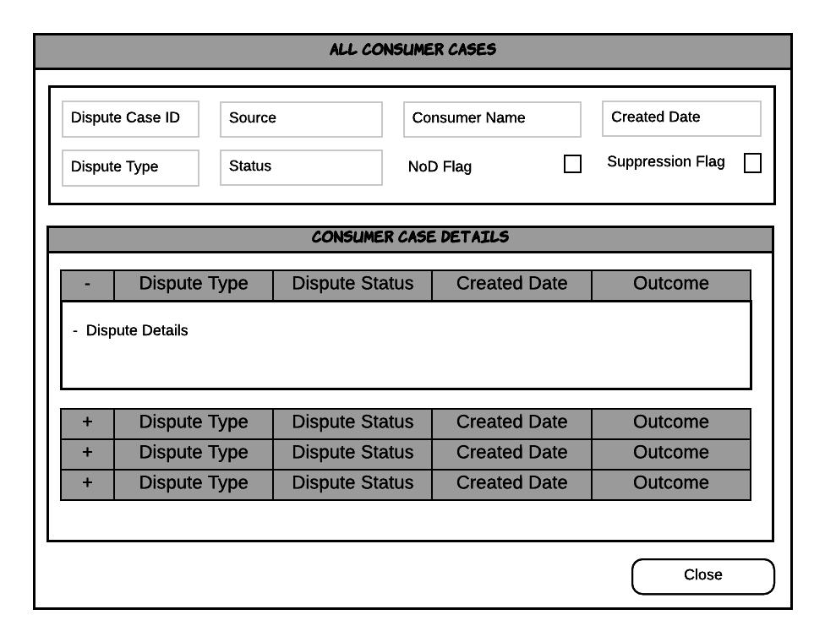

**Note:** It is recommended that rules are applied to View All Cases to restrict the potential volume of cases returned.

### Dispute Details

This section shows the following details about the Dispute raised by the Consumer:

* Dispute ID
* Dispute Type
* Dispute Reason
* Source
* Supplier
* Dispute Line Item

There are a number of supporting screens available from the Dispute Details section detailed below.

#### View Credit Report

An agent is able to view and search the consumer’s (and where appropriate, the associate’s) credit report in order to investigate and resolve the Dispute case. Dependant on the Dispute Type and investigation required an agent is able to:

* View the full credit report
* View a subset of the credit report, e.g. items based on a specific address/alias etc.
* View associates credit report for Associate Link disputes
* View the specific disputed item

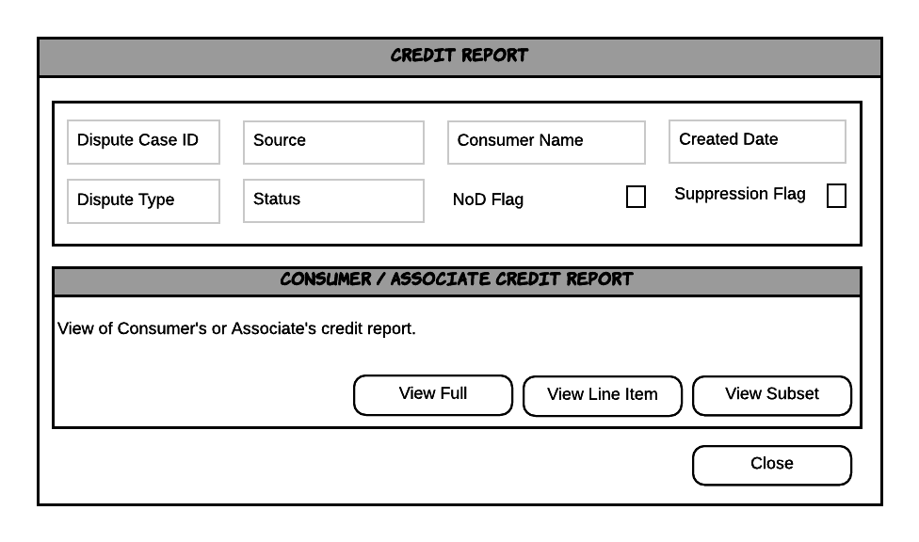

#### View Auto Processing

Numero attempts to auto process the Dispute case when it is received. Auto processing is performed against a set of rules defined in the Dispute Auto Processing section. Where auto processing has not been possible the View Auto Processing screen displays the auto processing rules results to help the agent with the decisioning process.

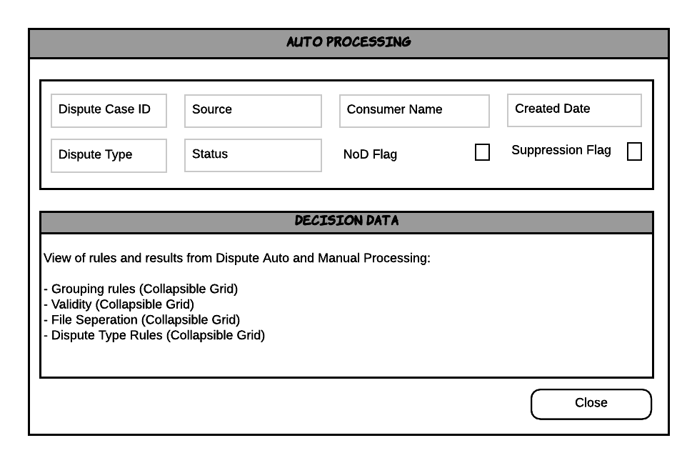

#### Linked Disputes

If the Dispute case currently being worked on has been linked to any other numero cases the Linked Cases screen provides a summary view of the linked cases.

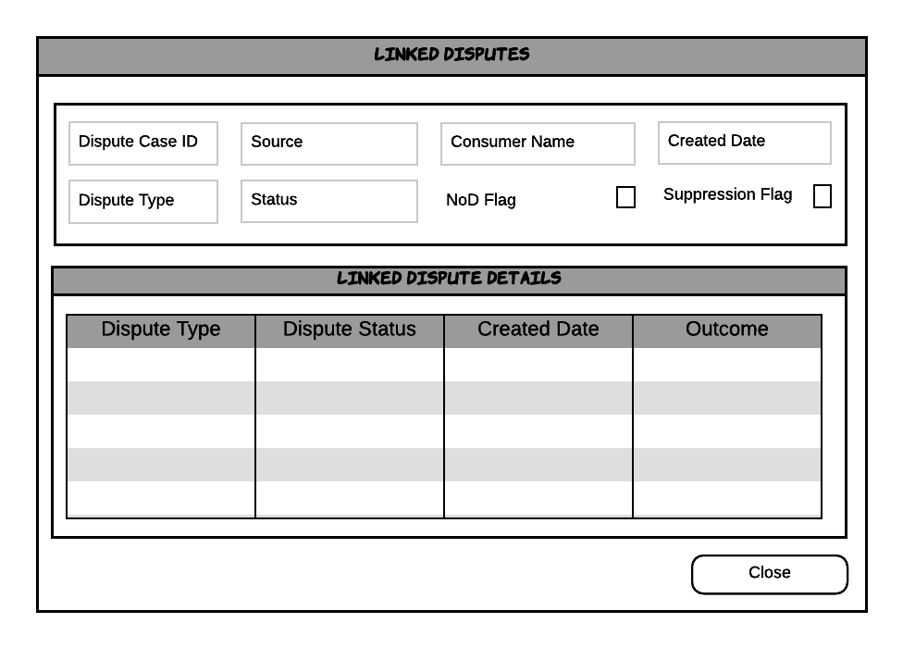

#### View File Merge

During auto processing checks are made to compare the consumer’s name and date of birth against all other credit report line items to identify if there is a potential file merge. Should a potential file merge be identified the View File Merge screen displays those items that differ. This enables the agent to make a quick decision on whether the case should be handled as a file merge.

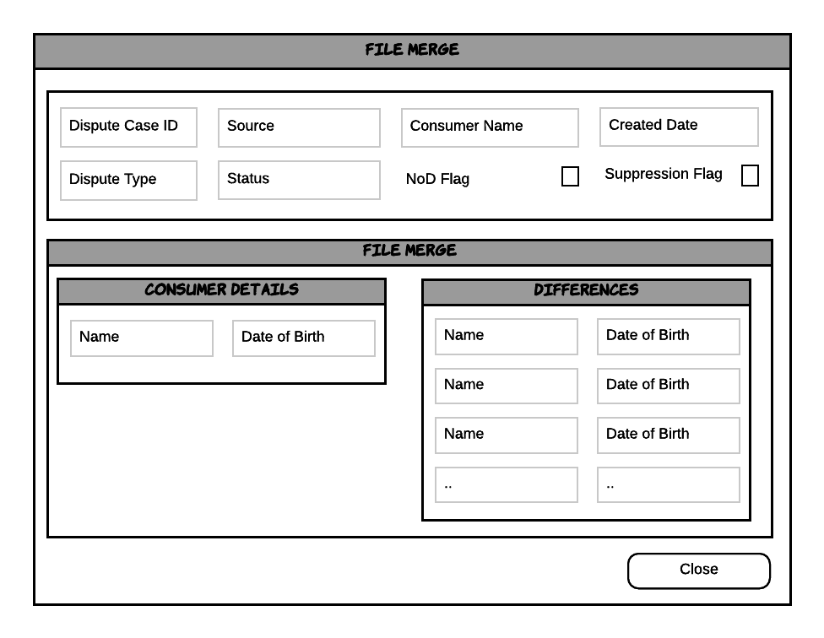

#### View Supplier(s)

The View Supplier(s) screen provides a view of the supplier(s) who sourced the disputed line item and whether the suppliers have been contacted and subsequently responded.

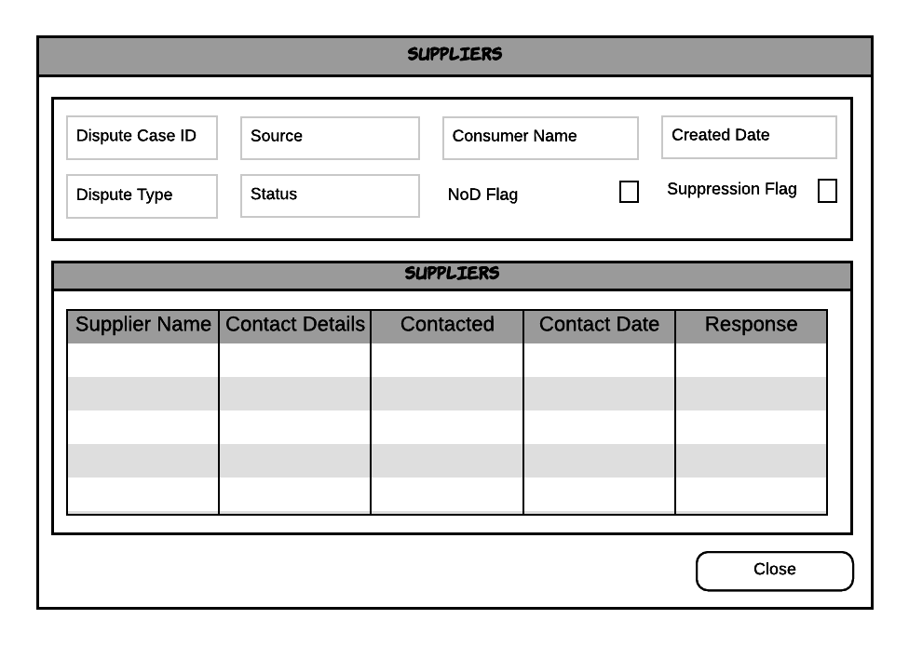

#### Noddle Admin

For Disputes raised via Noddle the agent may require access to the Noddle Admin panel when handling the case. The Noddle Admin button launches the Noddle Admin panel in a separate window.

**Note:** Future integration may allow for parameters to be passed to the Noddle Admin panel to automatically launch on the consumer admin screen.

### Case Actioning

The Case Actioning section is used to log answers to specific case handling questions in order to drive the next case action. The decision trees are described in section Case Actioning*.*

#### Required Action

The Required Action button is dynamic based on the answers to the questions provided by the advisor. At the end of each decision tree there should only be 1 action available.

### Case Stats

The Case Stats section displays key information about the case, this includes:

* Creation date
* Last action date
* Last actioned by
* Number of days open
* Number of open workitems in case
* Handling time

### Case History

The case history section details all of the interactions with a case from agents and the system. The following history events are logged:

* Case created
* Case viewed
* View all cases
* View credit report
  + Full
  + Subset
  + Associate
  + Disputed item
* View auto processing
* View linked disputes
* View file merge
* View suppliers
* Opened Noddle Admin
* Case Actioning
  + Answered question
  + Selected Required Action
* Updated case status
* Updated case reason
* Added a comment

Each event logs the date and time the event occurred, who triggered the event and any additional information required, such as field values set.

### Form Usage

* Used within the Consumer Data Processing From Triage Process
* Used within the Receive Correspondence Process

## Dispute Case Home Supplier Response

The Dispute Case Home Supplier Response form provides the same features and functionality as the Dispute Case Home form. In addition, it presents the supplier responses at the top level to enable the agent to quickly review and make a decision on the next steps.

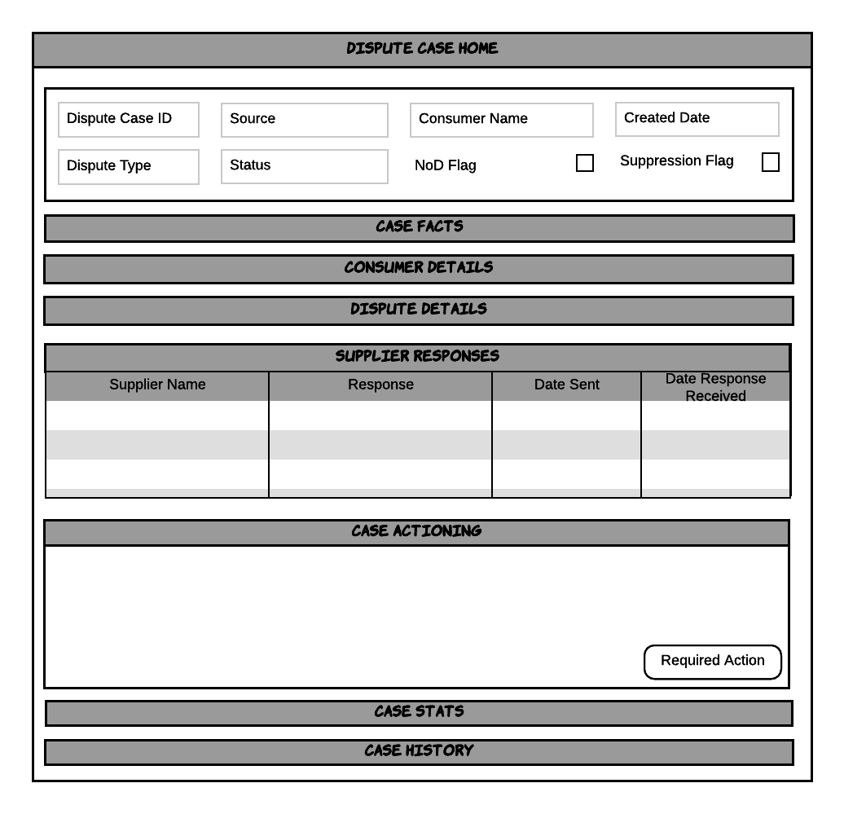

### Supplier Responses

The supplier responses section displays all of the suppliers that have been contacted as part of the Dispute case and their responses.

### Case Actioning

The Case Actioning section is used to log answers to specific case handling questions in order to drive the next case action. The decision trees for checking Supplier responses are described in section Check Supplier Responses*.*

### Form Usage

* Used within the Consumer Data Processing From Supplier Process

## Data Update Request

The Data Update Request form allows the agent to complete and submit a request to update the Credit Report data based on the results of the Dispute case investigation.

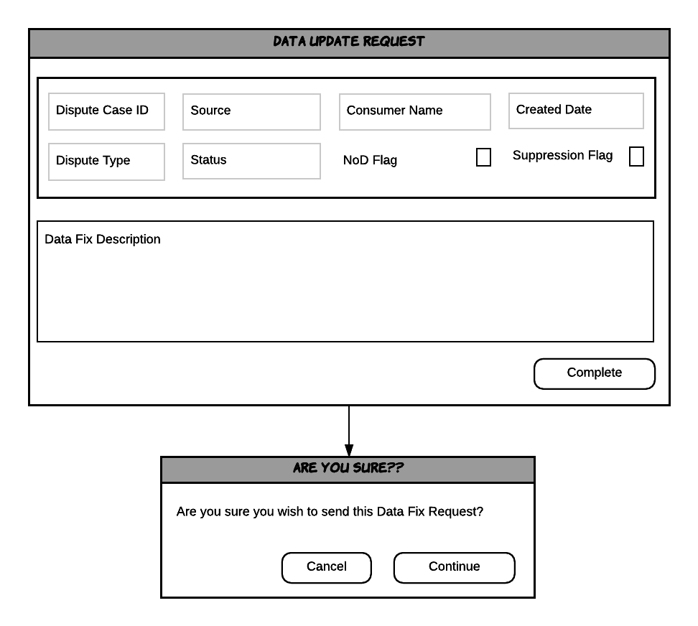

### Data Fix Description

All of the required data is present on the Dispute case and submitted with the request. The agent can include, where necessary, a free text description of the update before completing the request.

### Confirmation

Before the request is submitted the agent is asked to confirm they are happy to proceed. This final check provides the agent with an opportunity to cancel the request and return to the Dispute Case Handling form.

### Form Usage

* Used within the Consumer Data Processing From Triage Process
* Used within the Consumer Data Processing From Supplier Process
* Used within the Consumer Data Processing From Data Services Process
* Used within the Exception Handling Process

## Send to Suppliers

The Send to Suppliers form allows the agent to pass the Dispute case to the supplier(s) of the disputed data.

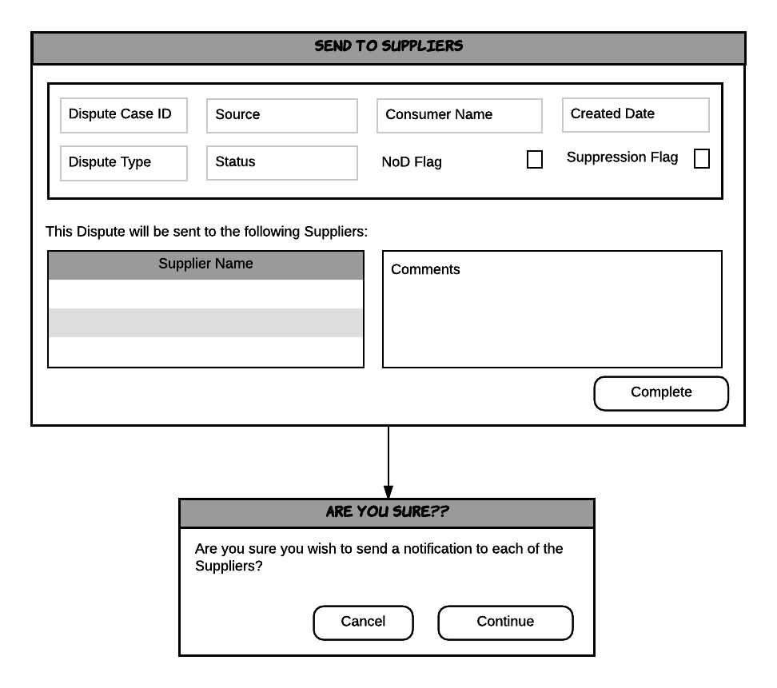

### Supplier Details

The supplier details grid contains the list of suppliers that the Dispute case will be sent to. As all suppliers access the Supplier Portal to access their Dispute cases there is no need to view the contact details.

### Comments

The agent can add free text comments to assist the suppliers when processing the dispute case.

### Confirmation

Before the case is passed to the suppliers the agent is asked to confirm they are happy to proceed. This final check provides the agent with an opportunity to cancel the request and return to the Dispute Case Handling form.

### Form Usage

* Used within the Consumer Data Processing From Triage Process

## Data Services Case Home

The Data Services Case Home form is a cut-down version of the Dispute Case Home form. See section Dispute Case Home. It provides all of the required Dispute case data to enable to the Data Service agent to action the data update.

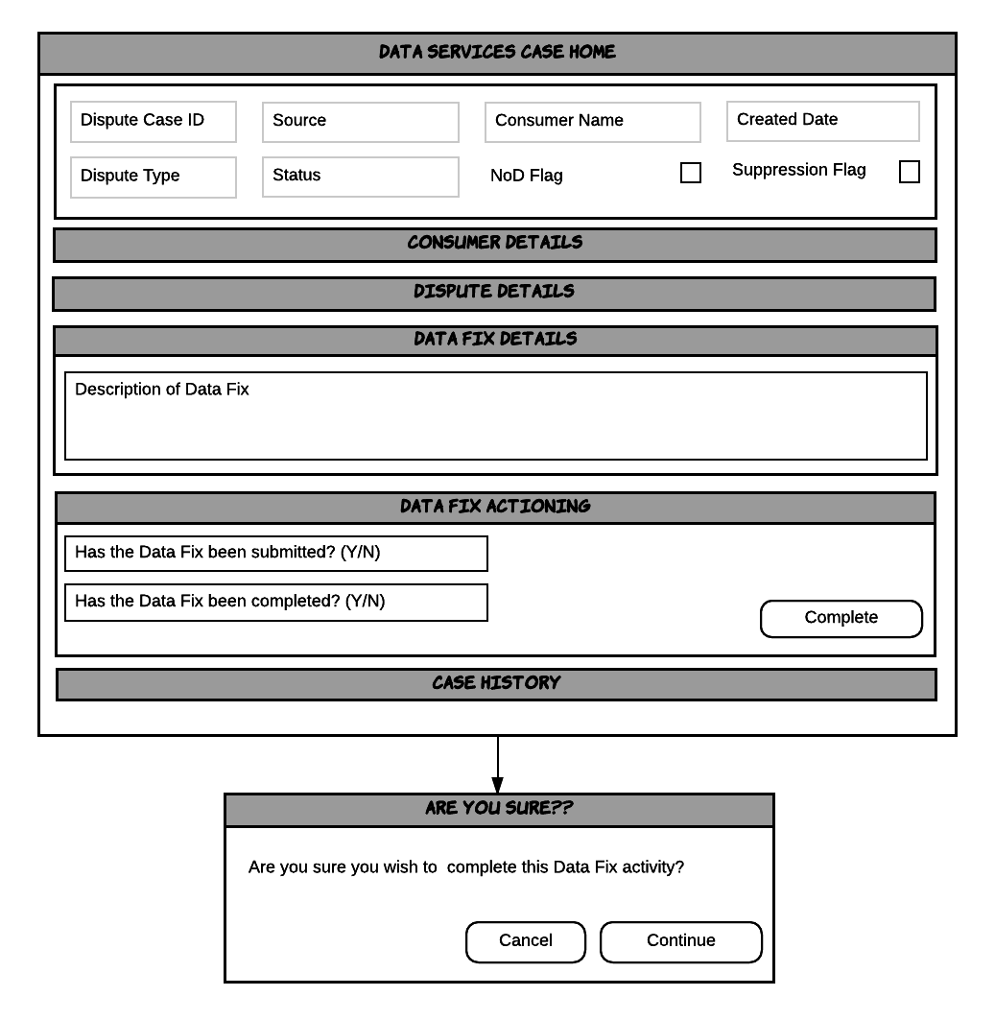

### Data Fix Details

The Data Fix details section displays the free text information provided by the Consumer Data Processing agent when submitting the request.

### Case Actioning

The Case Actioning section is used to log answers to specific case handling questions in order to drive the next case action. Data Services updates are managed as a 2 step process. Initially the agent is asked to confirm the update request has been submitted, completing the first stage of the handling. The second stage is for the agent to confirm that the update has been made.

### Confirmation

Before the request is submitted the agent is asked to confirm they are happy to proceed. This final check provides the agent with an opportunity to cancel the request and return to the Data Services Case Home form.

### Form Usage

* Used within the Data Services Processing Process.

## File Merge Request

The File Merge Request form allows the agent to complete and submit a request to separate a consumer’s credit report data.

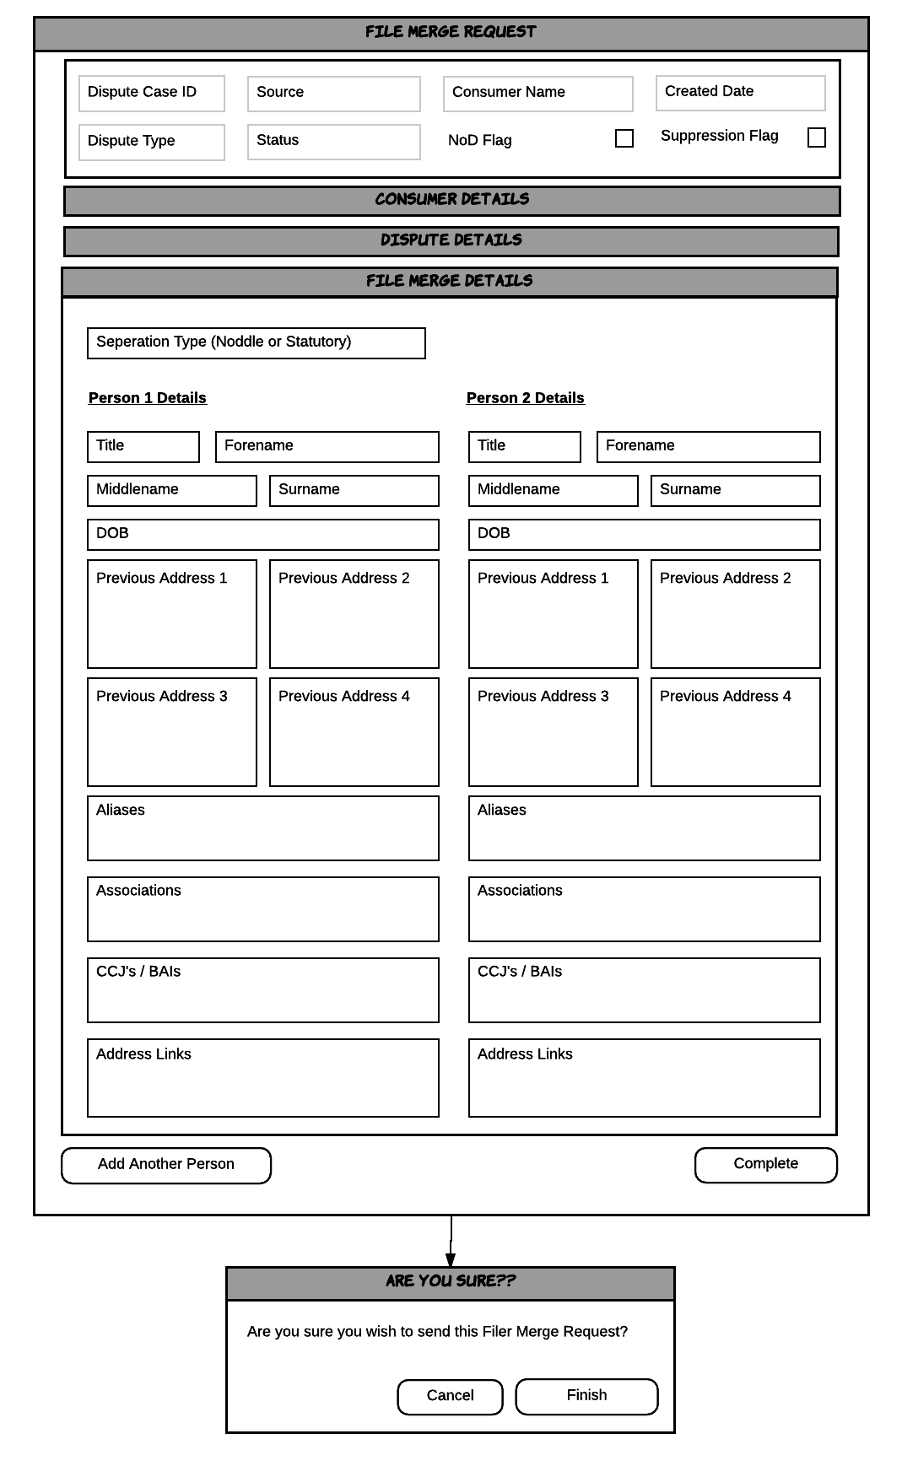

### File Merge Details

The agent must complete the file merge details form to assist Data Services with how the files should be separated. Where possible numero will automatically populate the form. The agent can select to add further people to the file merge request.

### Confirmation

Before the case is passed to the Data Services the agent is asked to confirm they are happy to proceed. This final check provides the agent with an opportunity to cancel the request and return to the Dispute Case Handling form.

### Form Usage

* Used within the Consumer Data Processing From Triage Process
* Used within the Consumer Data Processing From Triage Process

## Dispute Case Home Exception Handling

The Dispute Case Home Exception Handling form provides the same features and functionality as the Dispute Case Home form. See section Dispute Case Home.

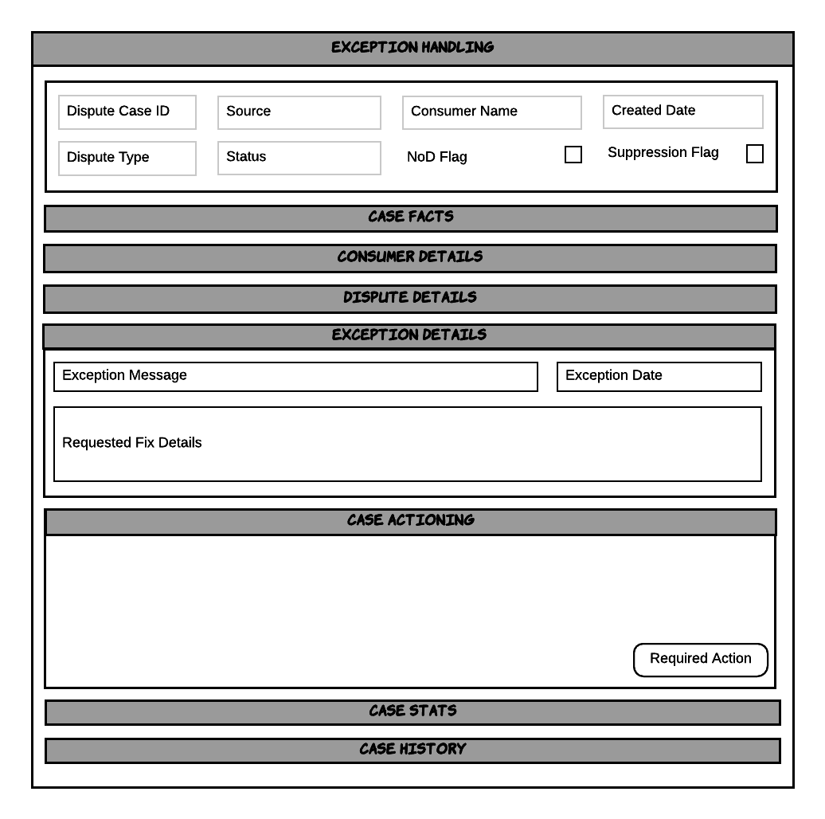

### Exception Details

The exception details section displays the exception message, the date the exception occurred and details on the data fix that was requested.

### Case Actioning

The Case Actioning section is used to log answers to specific case handling questions in order to drive the next case action. The decision trees for checking Supplier responses are described in section Exceptions*.*

### Form Usage

* Used within the Exception Handling Process.

## Complete

The Complete form is displayed at the end of each handling workflow when the agent has determined the next action.

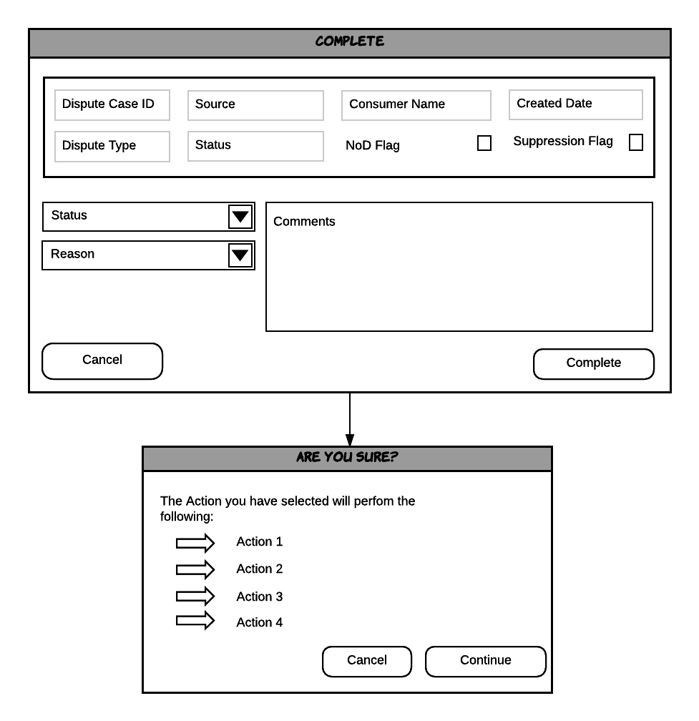

### Status

Where possible the status is automatically set based on the stage of the Dispute processing. See section State Model. However, in some circumstances this may not be possible and the agent is responsible for selecting the appropriate status.

### Reason

When a Dispute is unsuccessful or rejected the agent must select a reason. The reason is not required when selecting open Dispute case statuses.

### Comments

The agent is able to enter free text comments to provide further information on the action that they have taken.

### Confirmation

Before completing the workitem and/or case the agent is presented with a summary of what will happen once the workitem and/or case is completed. This final check provides the agent with an opportunity to cancel the completion and return to the Dispute Case Handling form.

### Form Usage

* Used within the Consumer Data Processing From Triage Process
* Used within the Consumer Data Processing From Supplier Process
* Used within the Data Services Processing Process
* Used within the Consumer Data Processing From Data Services Process
* Used within the Dispute SLA Monitor Process
* Used within the Exception Handling Process
* Used within the Receive Correspondence Process
* Used within the Dispute Triage Process

# Case Actioning

The following section details the decision trees used to determine the next case action. The white decision points represent questions presented to the agent.

The Case Actioning decision trees are referenced from the following sections:

* Consumer Data Processing From Triage
* Consumer Data Processing From Supplier
* Consumer Data Processing From Data Services
* Data Services Processing
* Exception Handling
* Receive Correspondence

## All Dispute Types

This decision process applies to all Disputes, regardless of type.

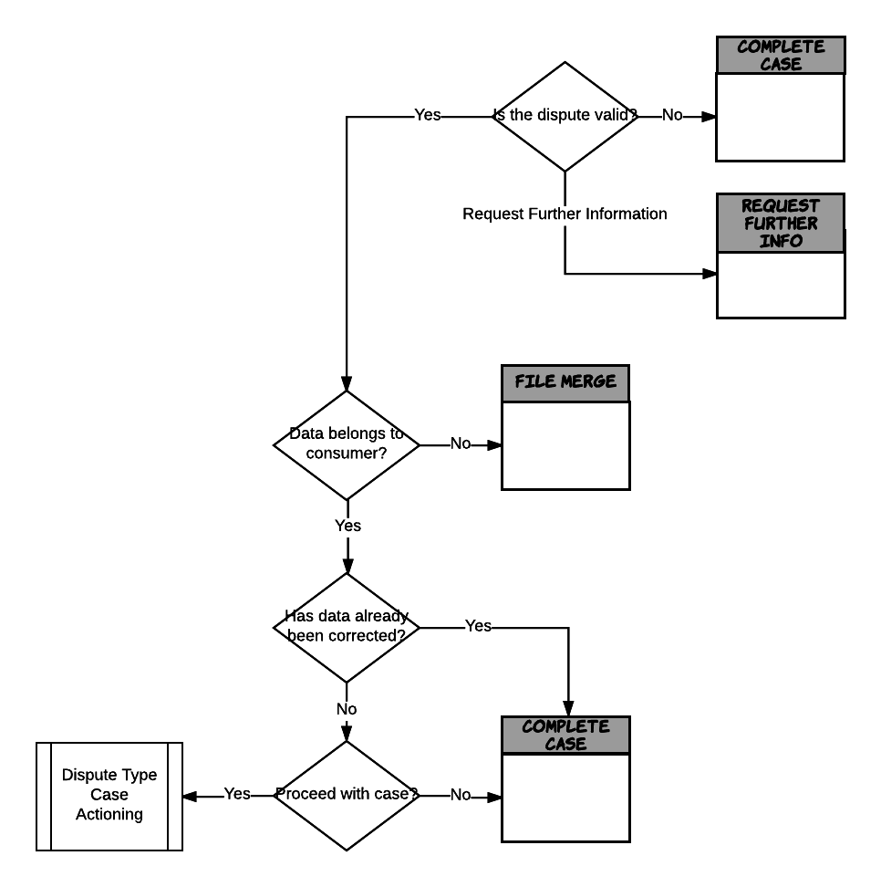

### Is the dispute valid?

The first step is to determine if this is a valid Dispute. The agent should use the same rules as those applied in the auto processing steps in Dispute Triage. See section Dispute Auto Processing.

### Data belongs to consumer?

If the Dispute is valid the next step is to investigate if there is a potential file merge.

### Has the data already been corrected?

It is possible that the data has been corrected between the Dispute being raised and the agent investigating the case. If this occurs the agent is able to complete the case successfully without proceeding to the type specific actioning questions.

### Proceed with case?

If the case is valid, a file merge has not been identified and the data has not already been corrected the agent selects whether to proceed with the case or to complete the case as unsuccessful at this point.

If the Agent selects to proceed with the case the Dispute Type specific actioning questions are presented as described below.

## Address Link

This decision process applies to Address Link Dispute types.

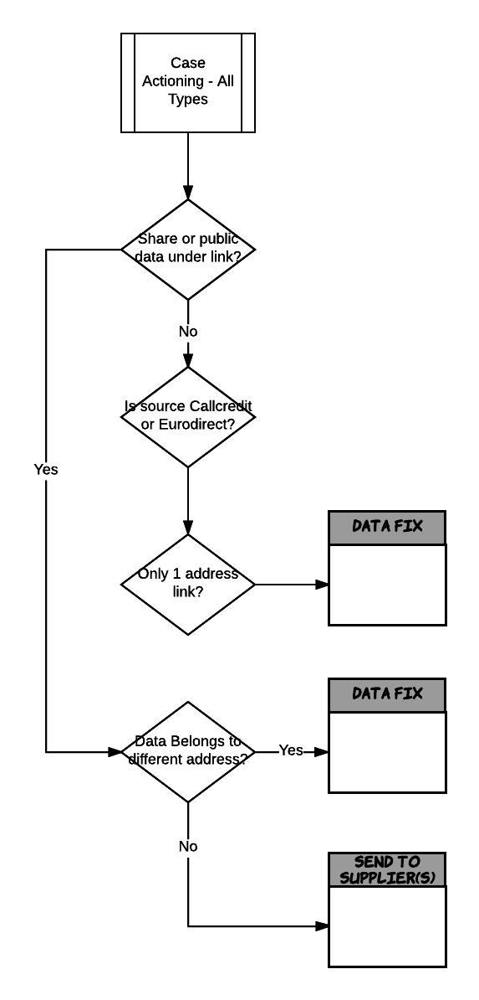

### Share or public data under link?

If the disputed link does not have any share or public data attached to it the Dispute can be sent for data fix.

### Is source Callcredit or Eurodirect?

The answer to this question is for MI purposes only.

### Only 1 address link?

If there is only 1 address link affected by the dispute the Dispute can be processed automatically, otherwise it is sent to Data Services for processing.

### Data belongs to different address?

If there is share or public data attached to the address link the agent determines if the data belongs to a different address. If so the case is routed to Data Services to action a Person Move, otherwise the Dispute case is sent to all of the suppliers to resolve.

## Alias Link

This decision process applies to Alias Link Dispute types.

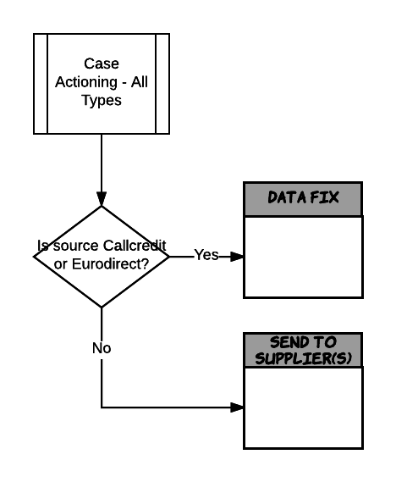

### Is the source Callcredit or Eurodirect?

If the agent identifies the source of the Alias link is Callcredit or Eurodirect the Dispute can be submitted for data fix. Otherwise the Dispute case is sent to all of the suppliers to resolve.

## Associate Link

This decision process applies to Associate Link Dispute types that have passed the All Dispute Types decisioning.

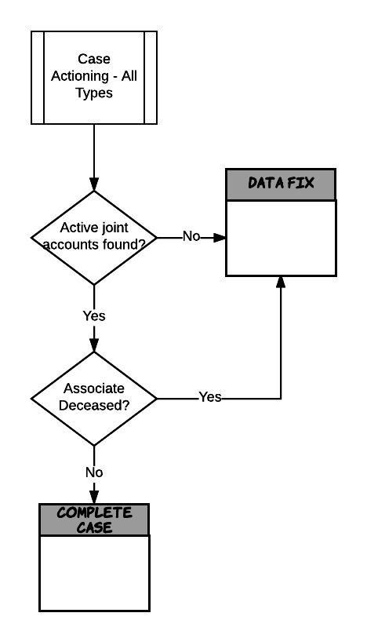

### Active joint accounts found?

If the agent identifies there are no active joint accounts found, where the account is inactive on one or both of the consumer’s and associate’s credit report the Dispute can be sent to Data Fix.

### Associate Deceased

Where there are active accounts found but the associate is marked as deceased the Dispute case can be sent to Data Fix. Otherwise the case is completed as unsuccessful.

## Public

This decision process applies to Public Dispute types.

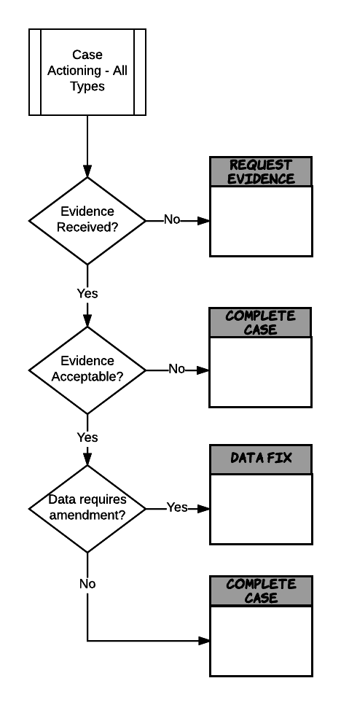

### Evidence received?

If supporting evidence has not been attached to the Dispute case the agent has to request the evidence.

### Evidence acceptable?

Where evidence has been submitted the agent must determine if the evidence is acceptable. If not the case is completed as unsuccessful.

### Data requires amendment?

If the evidence provided is acceptable the agent ascertains if a data fix is required. If it is then the case is submitted to data fix. Otherwise the case is closed unsuccessful.

## Search

This decision process applies to Search Dispute types that have passed the All Dispute Types decisioning.

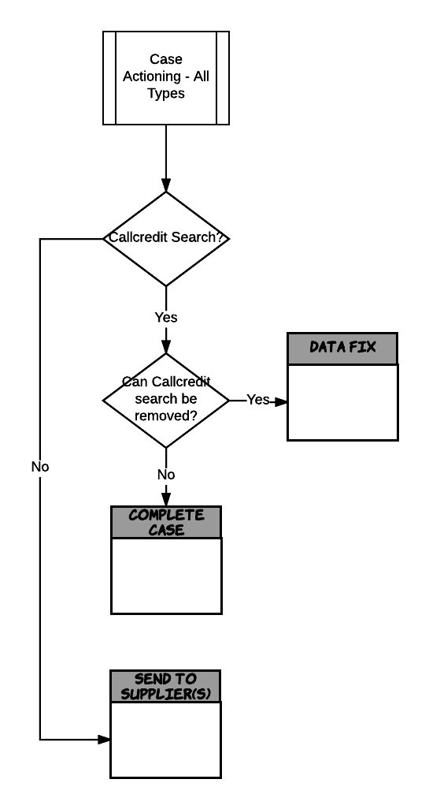

### Callcredit search

If the source of the search is Callcredit then the Dispute is in scope for an immediate data fix. If Callcredit is not the source the Dispute case is sent to the supplier to resolve.

### Can Callcredit search be removed?

To determine if the search can be removed the agent should use the same rules as those applied in the auto processing steps in Dispute Triage. See section Dispute Auto Processing. If the dispute can be removed it is sent for data fix otherwise it is closed unsuccessful.

## Share/MODA

This decision process applies to Public Link Dispute types that have passed the All Dispute Types decisioning.

All Share/MODA disputes are routed to the supplier to resolve.

## Exceptions

If a data fix exception is raised an agent is responsible for determining how to handle the exception.

This decision tree is referenced from the Exception Handling section.

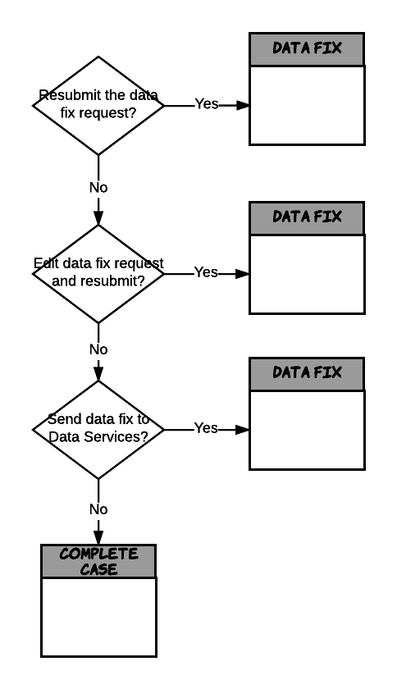

### Resubmit the data fix request?

Based on the exception message can the data fix request be resubmitted without any amendments?

### Edit data fix request and resubmit?

Based on the exception message does the data fix request need to be amended before resubmitting?

### Send the fix to Data Services?

If the data fix cannot be resubmitted does it need to be routed to Data Services to action the fix or does the data fix request need to be cancelled?

## Check Data Services Fix

When Data Services confirm a data fix has been completed a Consumer Data Processing agent checks the fix has been applied correctly.

This decision tree is referenced from the Consumer Data Processing From Data Services section.

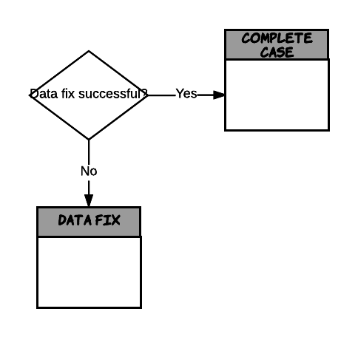

### Data Fix Successful?

If the agent confirms the data fix is successful the case is completed. Otherwise it is sent back to Data Services.

## Check Supplier Responses

When all of the required supplier responses have been received (or the SLA Process has been invoked) a Consumer Data Processing agent is responsible for checking and processing the responses and non-responses.

This decision tree is referenced from the Consumer Data Processing From Supplier section.

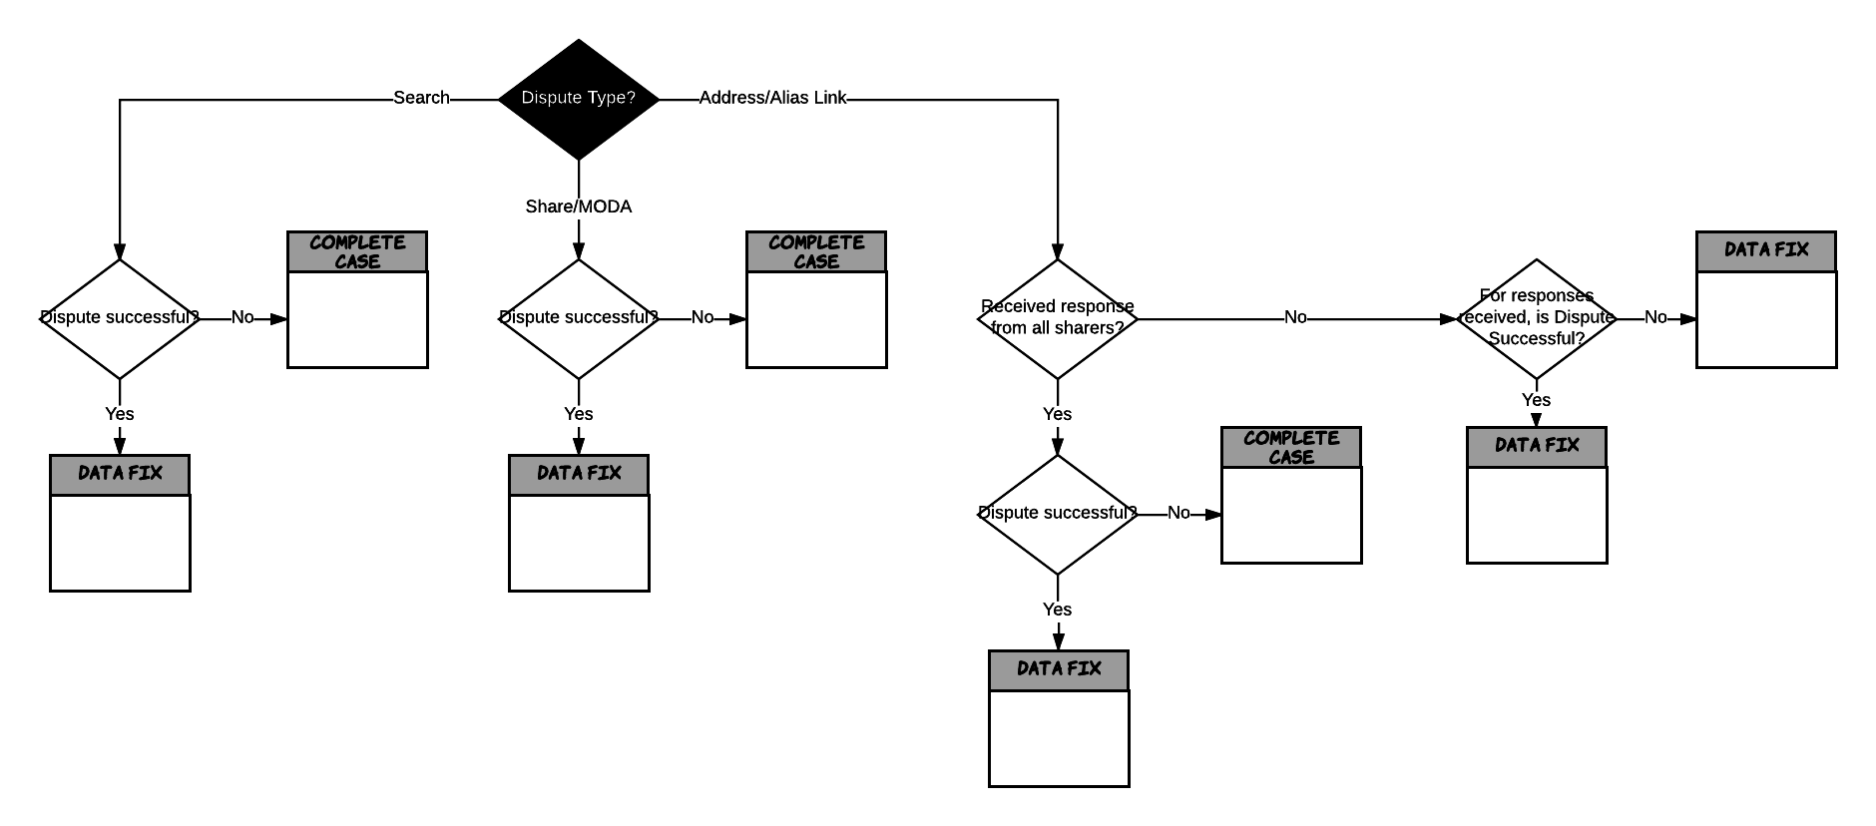

### Search Dispute

#### Dispute Successful?

If the Supplier has accepted the Dispute the case can be routed to Data Fix. Otherwise the case is closed unsuccessful.

### Share/MODA Dispute

#### Dispute Successful?

If the Supplier has accepted the Dispute the case can be routed to Data Fix. Otherwise the case is closed unsuccessful.

### Address/Alias Link Dispute

#### Received responses from all Suppliers?

If all of the required suppliers have responded a decision on the case can be made.

#### Dispute Successful?

If all the suppliers have provided the same outcome the dispute case can either be sent for data fix in the event of success or the case completed in the event of unsuccessful.

#### For responses received is Dispute successful?

Success responses and no response require the case to be sent for Data Fix to remove the data. Responses of unsuccessful are not processed.

# Work Distribution

numero recommend day-to-day work distribution is achieved by allocating numero users to Groups. Groups represent types (categories) of work received into numero, and are also split by channel; this ensures that numero users only receive work items relevant to their skill set and function.

The following are key work distribution principles which numero interactive will embody:

* Dispute Type (mapped to Workitem Category) is used to distribute Disputes to the correct handling Agent.
* All Agents can work all Companies
* Dispute case status to be mapped as a numero Skill to enable distribution, specifically:
  + Awaiting Investigation (new cases waiting manual triage)
  + Awaiting Consumer Response Review
  + Awaiting Supplier Response Review
* All new Dispute Enquiries are handled by the CST in Leeds.
* All inbound workitems received into an existing Dispute Case inherit the category and are therefore actioned by the Consumer Data Processing Team in Kaunas.

# Management Information

## Standard Reports

The following reports are provided as standard with numero interactive:

* User Performance Summary
  + This report shows the activity of all users who worked on numero interactive between the dates specified. The report is by CCCO and day. The information gives a summary of each user’s activity over the period. To obtain detailed information at the user level, click on the name of the appropriate user to view the **User Counts** and **User Times** sub reports. When viewing figures on this report note that the total number of work items offered will not always tally with the number of work items handled.
* Weekly Volumes
  + This report shows the volume of work received and sent by numero interactive. The report is initially broken down by company.
* Work Item Aged Report
  + This report shows the amount of open work and the length of time the work has been open. The report is grouped by company, category, channel, outcome and work item id and shows how old the work is in weeks.
* Work Closed Summary
  + This report shows information about work closed between the dates specified. The report is grouped by CCC. Click on a company to drill into an additional breakdown by category for that company.
* Category Allocation
  + This report shows the number of closed work items that were initially allocated to each category and the number which were subsequently moved to another category by an Advisor. The report is by category for the specified period. The count of work items re-categorised only includes the first manual change, and further re-categorisation is ignored. The start and end date parameters restrict the work items based on their creation date. Changes to category after the end date are included in this report. All percentages on this report are relative to the total number of messages closed in the report period.
* Case Age Report
  + This report shows the number of open cases and how long the cases have been open. The report is grouped by channel, company and category where these attributes are taken from the last inbound work item in the case. The age of the cases is shown in weeks. Click the expand button on a week to drill into the age in days.
* Cases Closed Summary
  + This report shows information about cases closed between the dates specified. The report is by channel, company and category where these attributes are taken from the last inbound work item in the case. Click on a company to drill into an additional breakdown by category for that company.

## Bespoke Reports

* Dispute Case Volume Report
  + This report will show totals for the number of Dispute Cases created within a selected time period. There will be a parameter for Dispute Type and/or Dispute Source. As a minimum the fields that will be included are:
    - Company
    - Category (Dispute Type)
    - Dispute Source
    - Case Status
    - Week Commencing
  + The report will be grouped by:
    - Company
    - Category (Dispute Type)
    - Dispute Source
    - Week Commencing
* Dispute Case SLA Report
  + This report will show the number of open Dispute Cases created for a selected time period, and perform calculations based on the pre-determined SLA. There will also be a parameter for Dispute Type and/or Dispute Source. As a minimum, the fields that will be included are:
    - Company
    - Category (Dispute Type)
    - Dispute Source
    - Created Date
    - Case Status
    - Last Actioned Date
    - SLA (Working Days)
    - SLA Status
  + The report will be grouped by:
    - Company
    - Category (Dispute Type)
    - Dispute Source
* Dispute Case Age Report
  + This report will show the number of open Dispute Cases created for a selected time period and indicate the how long they have been outstanding for. There will also be a parameter for Dispute Type and/or Dispute Source. As a minimum, the fields that will be included are:
    - Company
    - Category (Dispute Type)
    - Dispute Source
    - Created Date
    - Last Actioned Date
    - Case Status
    - Case Age (Days)
  + The report will be grouped by:
    - Company
    - Category (Dispute Type)
    - Dispute Source

## BI Extracts

Numero will provide a regular data extract to BI. The frequency of the extract and the data provided are to be determined during the build phase.